CSS Basics – ll [HD]

CSS Gradients

Html part:

1.Linear Gradient

<!DOCTYPE html>

<html lang="en">

<head>

    <meta charset="UTF-8">

    <meta http-equiv="X-UA-Compatible" content="IE=edge">

    <meta name="viewport" content="width=device-width, initial-scale=1.0">

    <title>Document</title>

    <link rel="stylesheet" href="/addStyle/css2_1.css">

</head>

<body>

    <div class="box1">box1  Linear  Gradient by default</div>

    <hr>

    <div class="box2">box2 Linear Gradient =to bottom</div>

    <hr>

    <div class="box3">box3 Linear Gradient =to top</div>

    <hr>

    <div class="box4">box4 Linear Gradient =to left</div>

    <hr>

    <div class="box5">box5 Linear Gradient =to right</div>

    <hr>

    <div class="box6">box6 Linear Gradient = to bottom right</div>

    <hr>

    <div class="box7">box7 Linear Gradient = to top right</div>

    <hr>

    <div class="box8">box8 Linear Gradient = using tranparancy</div>

</body>

</html>

CSS part :

.box1{

    border: 1px solid black;

    height: 100px;

    width: 100px;

    background-image: linear-gradient(red,green);

}

.box2{

    border: 1px solid black;

    height: 100px;

    width: 100px;

    background-image: linear-gradient(to bottom,red,blue);

}

.box3{

    border: 1px solid black;

    height: 100px;

    width: 100px;

    background-image: linear-gradient(to top,red,blue);

}

.box4{

    border: 1px solid black;

    height: 100px;

    width: 100px;

    background-image: linear-gradient(to left,red,blue);

}

.box5{

    border: 1px solid black;

    height: 100px;

    width: 100px;

    background-image: linear-gradient(to right,red,blue);

}

.box6{

    border: 1px solid black;

    height: 100px;

    width: 100px;

    background-image: linear-gradient(to bottom right,orange,green,red);

}

.box7{

    border: 1px solid black;

    height: 100px;

    width: 100px;

    background-image: linear-gradient(to top right,orange,green,red);

}

.box8{

    border: 1px solid black;

    height: 100px;

    width: 100px;

    background-image: linear-gradient(to  bottom,rgba(255,0,0,0),rgba(0,0,255,1));

}

Output :

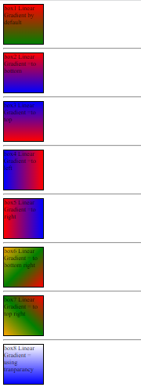

2.Radial Gradient

Html part :

<!DOCTYPE html>

<html lang="en">

<head>

    <meta charset="UTF-8">

    <meta http-equiv="X-UA-Compatible" content="IE=edge">

    <meta name="viewport" content="width=device-width, initial-scale=1.0">

    <title>Document</title>

    <link rel="stylesheet" href="/addStyle/html2_2.css">

</head>

<body>

    <div class="box1">box1 radial gradients </div>

    <hr>

    <div class="box2">box2 radial gradients =circle</div>

    <hr>

    <div class="box3">box2 radial gradients </div>

</body>

</html>

CSS part :

.box1{

    border: 1px solid black;

    height: 400px;

    width: 200px;

    background-image: radial-gradient(red,green,blue);

}

.box2{

    border: 1px solid black;

    height: 400px;

    width: 200px;

    background-image: radial-gradient(circle,red,green,blue);

}

.box3{

    border: 1px solid black;

    height: 400px;

    width: 200px;

    background-image: radial-gradient(red 5%,yellow 10%,#33CAFF 50%);

}

Output :

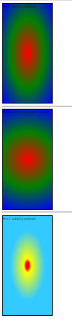

3.Conic Gradient (Home work)

Shadow

Html :

<!DOCTYPE html>

<html lang="en">

<head>

    <meta charset="UTF-8">

    <meta http-equiv="X-UA-Compatible" content="IE=edge">

    <meta name="viewport" content="width=device-width, initial-scale=1.0">

    <title>Document</title>

    <link rel="stylesheet" href="/addStyle/html2_2.css">

</head>

<body>

    <div class="box4">this is box4 SHADOW</div>

    <hr>

    <div class="box5">this is box5 SHADOW</div>

    <hr>

    <div class="box6">this is box6 SHADOW</div>

    <hr>

    <div class="box7">this is box7 SHADOW</div>

    <hr>

    <div class="box8">this is box8 SHADOW</div>

    <hr>

</body>

</html>

Css :

.shadow-effect{

    text-shadow: 3px 3px 3px red,6px 6px 6px green;

}

.box4{

    background-color: #33CAFF;

    color: red;

    height: 200px;

    width: 200px;

    box-shadow: 10px 10px;

}

.box5{

    background-color: #33CAFF;

    color: red;

    height: 200px;

    width: 200px;

    box-shadow: 10px 10px green;

}

.box6{

    background-color: #33CAFF;

    color: red;

    height: 200px;

    width: 200px;

    box-shadow: 10px 10px 10px green;

}

.box7{

    background-color: #33CAFF;

    color: red;

    height: 200px;

    width: 200px;

    box-shadow: 10px 10px 10px green,15px 15px 15px orangered;

}

.box8{

    background-color: #33CAFF;

    color: red;

    height: 200px;

    width: 200px;

    box-shadow: -10px -10px 10px violet,15px 15px 15px orangered;

}

Output :

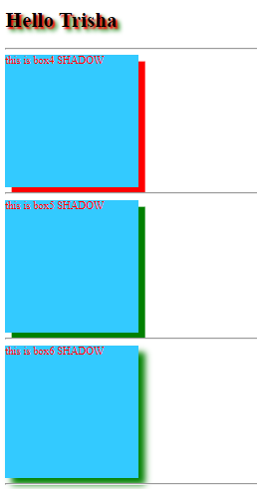

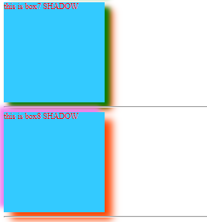

CSS Dimension properties

1.relative

Html :

<!DOCTYPE html>

<html lang="en">

<head>

    <meta charset="UTF-8">

    <meta http-equiv="X-UA-Compatible" content="IE=edge">

    <meta name="viewport" content="width=device-width, initial-scale=1.0">

    <title>Document</title>

    <link rel="stylesheet" href="/addStyle/html3_1.css">

</head>

<body>

    <div class="box">Z</div>

</body>

</html>

Css :

div{

    width: 100px;

    height: 100px;

    background-color: aquamarine;

    border:1px solid black;

   display: inline-block;

}

.box{

    position: relative;

    top: 100px;

    left: 50px;

}

Output :

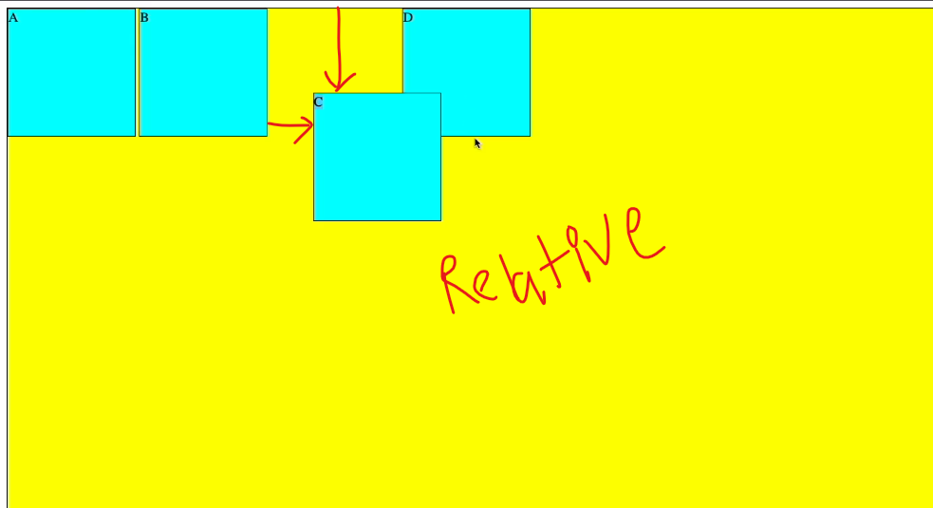

Position:relative work karta hai top,bottom,left aur right pe.

Html

<!DOCTYPE html>

<html lang="en">

<head>

    <meta charset="UTF-8">

    <meta http-equiv="X-UA-Compatible" content="IE=edge">

    <meta name="viewport" content="width=device-width, initial-scale=1.0">

    <title>Document</title>

    <link rel="stylesheet" href="/addStyle/html3_1.css">

</head>

<body>

    <div class="box" id="box1">A</div>

    <div class="box" id="box2">B</div>

    <div class="box" id="box3">C</div>

    <div class="box" id="box4">D</div>

</body>

</html>

Css

div{

    width: 100px;

    height: 100px;

    background-color: aquamarine;

    border:1px solid black;

   display: inline-block;

}

#box3{

    position: relative;

    top: 50px;

    right: 50px;

}

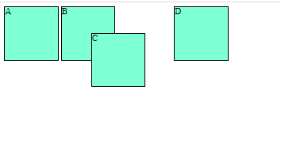

Fixed

Html

<!DOCTYPE html>

<html lang="en">

<head>

    <meta charset="UTF-8">

    <meta http-equiv="X-UA-Compatible" content="IE=edge">

    <meta name="viewport" content="width=device-width, initial-scale=1.0">

    <title>Document</title>

    <link rel="stylesheet" href="/addStyle/html3_1.css">

</head>

<body>

    <div class="wrapper">

        <div class="box" id="box1">A</div>

        <div class="box" id="box2">B</div>

        <div class="box" id="box3">C</div>

        <div class="box" id="box4">D</div>

    </div>

</body>

</html>

Css

div{

    width: 100px;

    height: 100px;

    background-color: aquamarine;

    border:1px solid black;

   display: inline-block;

}

#box3{

    position: relative;

    top: 50px;

    right: 50px;

}

#box1{

    position:fixed;

}

.wrapper{

    background-color: yellow;

    height: 20000px;

    width: 100vw;

}

Output

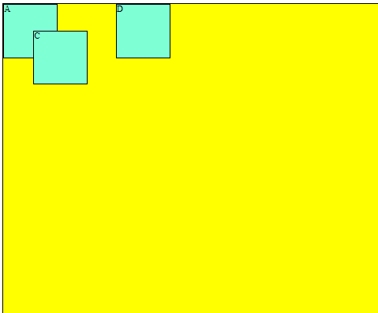

Fixed mai A ki position fixed ho jayegi

CSS Basics – lll [HD]

CSS FlexBox

Html :

<!DOCTYPE html>

<html lang="en">

<head>

    <meta charset="UTF-8">

    <meta http-equiv="X-UA-Compatible" content="IE=edge">

    <meta name="viewport" content="width=device-width, initial-scale=1.0">

    <title>Document</title>

    <link rel="stylesheet" href="/addStyle/html3_2.css">

</head>

<body>

    <div class="container">

        <div class="box" id="boxA">box-A</div>

        <div class="box" id="boxB">box-B</div>

        <div class="box" id="boxC">box-C</div>

        <div class="box" id="boxD">box-D</div>

    </div>

</body>

</html>

Css

.container{

    border: 1px solid green;

    height: 400px;

    display: flex;

}

.box{

    border:1px solid brown;

}

#boxA{

    background-color: cyan;

}

#boxB{

    background-color:blue;

}

#boxC{

    background-color:blueviolet;

}

#boxD{

    background-color:darkred;

}

Output :

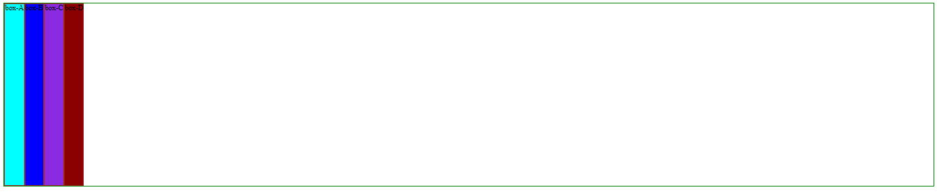

//Html code part is same but change in css part

Css

.container{

    border: 1px solid green;

    height: 400px;

    display: flex;

    flex-direction: column;

}

.box{

    border:1px solid brown;

}

#boxA{

    background-color: cyan;

}

#boxB{

    background-color:blue;

}

#boxC{

    background-color:blueviolet;

}

#boxD{

    background-color:darkred;

}

Output

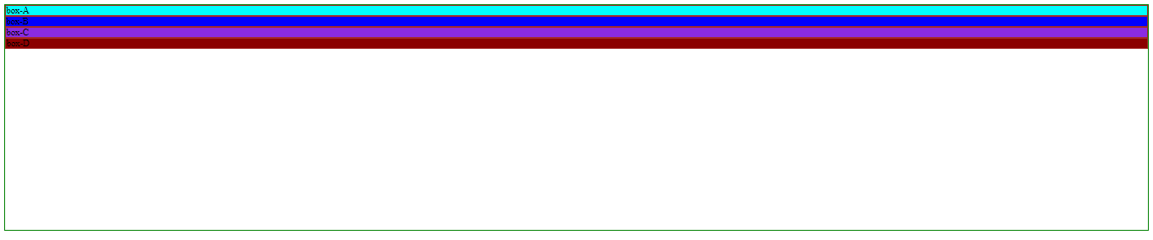

.container{

    border: 1px solid green;

    height: 400px;

    display: flex;

    flex-direction: column-reverse;

}

.box{

    border:1px solid brown;

}

#boxA{

    background-color: cyan;

}

#boxB{

    background-color:blue;

}

#boxC{

    background-color:blueviolet;

}

#boxD{

    background-color:darkred;

}

Output

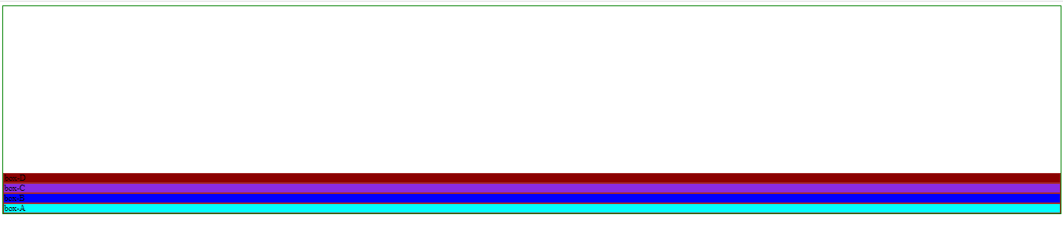

Css

.container{

    border: 1px solid green;

    height: 400px;

    display: flex;

    flex-direction: row;

}

.box{

    border:1px solid brown;

}

#boxA{

    background-color: cyan;

}

#boxB{

    background-color:blue;

}

#boxC{

    background-color:blueviolet;

}

#boxD{

    background-color:darkred;

}

Output

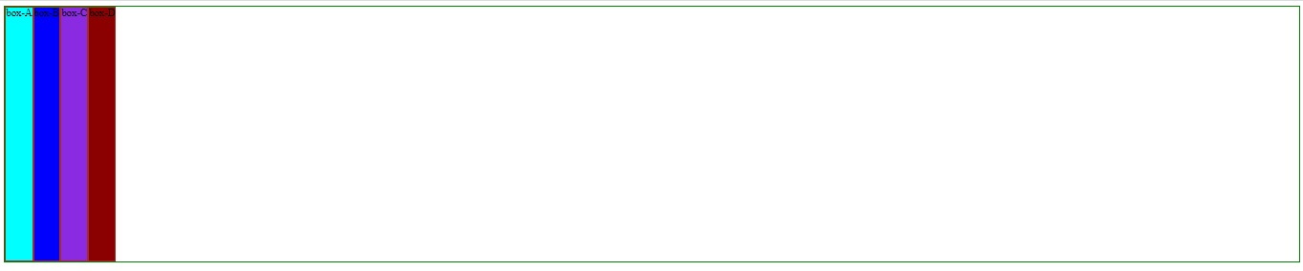

Css

.container{

    border: 1px solid green;

    height: 400px;

    display: flex;

    flex-direction: row-reverse;

}

.box{

    border:1px solid brown;

}

#boxA{

    background-color: cyan;

}

#boxB{

    background-color:blue;

}

#boxC{

    background-color:blueviolet;

}

#boxD{

    background-color:darkred;

}

Output

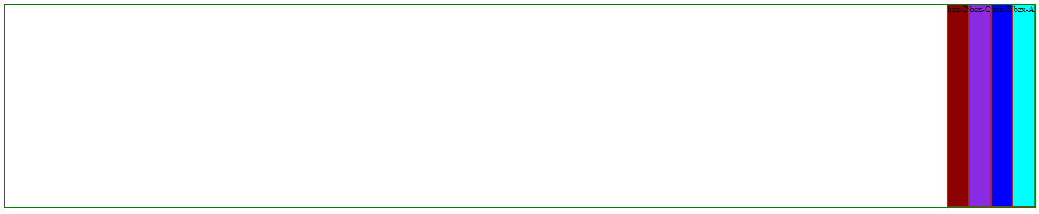

Css

.container{

    border: 1px solid green;

    height: 400px;

    display: flex;

    flex-wrap: wrap;

}

.box{

    border:1px solid brown;

    width: 200px;

}

#boxA{

    background-color: cyan;

}

#boxB{

    background-color:blue;

}

#boxC{

    background-color:blueviolet;

}

#boxD{

    background-color:darkred;

}

Output

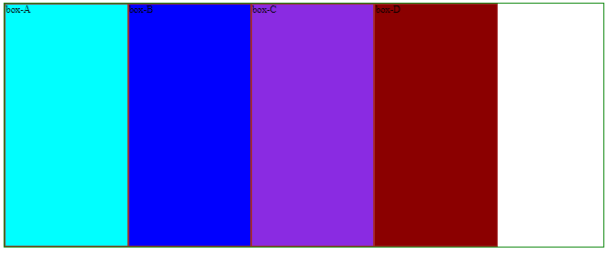

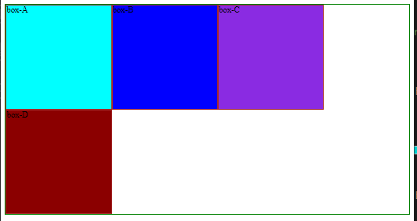

Css

.container{

    border: 1px solid green;

    height: 400px;

    display: flex;

    /* flex-direction: row-reverse; */

    flex-wrap: nowrap;

}

.box{

    border:1px solid brown;

    width: 200px;

}

#boxA{

    background-color: cyan;

}

#boxB{

    background-color:blue;

}

#boxC{

    background-color:blueviolet;

}

#boxD{

    background-color:darkred;

}

Output

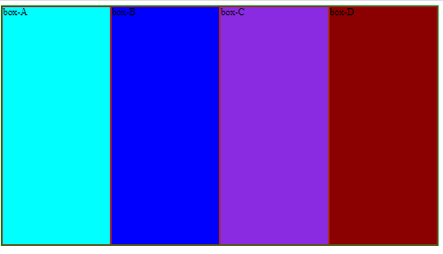

flex item ki width ko preserve karne ke liye flex-wrap ka use karte hai

.container{

    border: 1px solid green;

    height: 400px;

    display: flex;

    /* flex-direction: row-reverse; */

    flex-wrap: wrap-reverse;

}

.box{

    border:1px solid brown;

    width: 200px;

}

#boxA{

    background-color: cyan;

}

#boxB{

    background-color:blue;

}

#boxC{

    background-color:blueviolet;

}

#boxD{

    background-color:darkred;

}

Output :

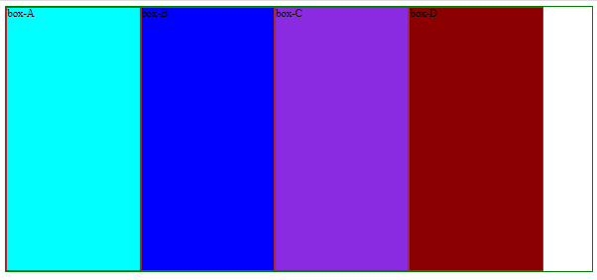

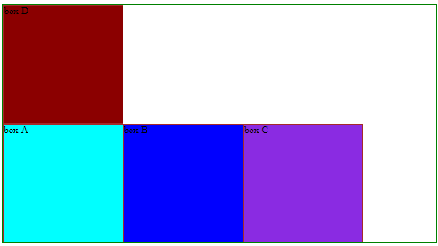

Using flex-flow is combination of flex direction and flex-wrap

flex-flow: row wrap;

Css

.container{

    border: 1px solid green;

    height: 400px;

    display: flex;

   flex-flow: row wrap;

}

.box{

    border:1px solid brown;

    width: 200px;

}

#boxA{

    background-color: cyan;

}

#boxB{

    background-color:blue;

}

#boxC{

    background-color:blueviolet;

}

#boxD{

    background-color:darkred;

}

Output :

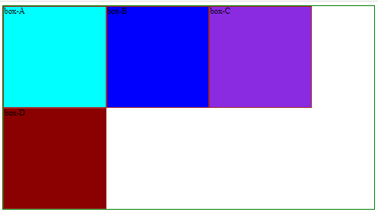

Css

.container{

    border: 1px solid green;

    height: 400px;

    display: flex;

    flex-wrap: wrap;

   justify-content: start;

}

.box{

    border:1px solid brown;

    width: 200px;

}

#boxA{

    background-color: cyan;

}

#boxB{

    background-color:blue;

}

#boxC{

    background-color:blueviolet;

}

#boxD{

    background-color:darkred;

}

Output

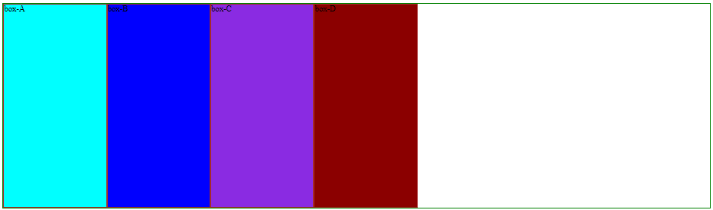

Note: aap ke main axis ke upar items ko align karta hai ,by default main axis horizontal hota hai.

Css

.container{

    border: 1px solid green;

    height: 400px;

    display: flex;

    flex-wrap: wrap;

   justify-content: end;

}

.box{

    border:1px solid brown;

    width: 200px;

}

#boxA{

    background-color: cyan;

}

#boxB{

    background-color:blue;

}

#boxC{

    background-color:blueviolet;

}

#boxD{

    background-color:darkred;

}

Output

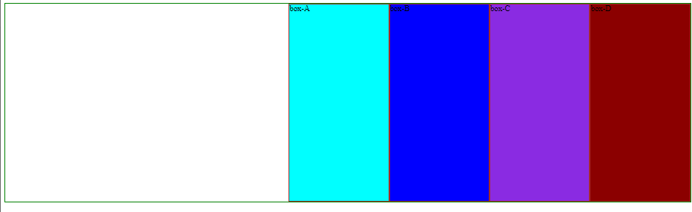

Css

.container{

    border: 1px solid green;

    height: 400px;

    display: flex;

    flex-wrap: wrap;

   justify-content: center;

}

.box{

    border:1px solid brown;

    width: 200px;

}

#boxA{

    background-color: cyan;

}

#boxB{

    background-color:blue;

}

#boxC{

    background-color:blueviolet;

}

#boxD{

    background-color:darkred;

}

Output

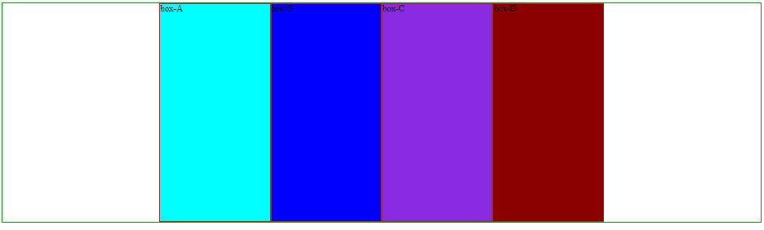

Css

.container{

    border: 1px solid green;

    height: 400px;

    display: flex;

    flex-wrap: wrap;

   justify-content: space-around;

}

.box{

    border:1px solid brown;

    width: 200px;

}

#boxA{

    background-color: cyan;

}

#boxB{

    background-color:blue;

}

#boxC{

    background-color:blueviolet;

}

#boxD{

    background-color:darkred;

}

Output

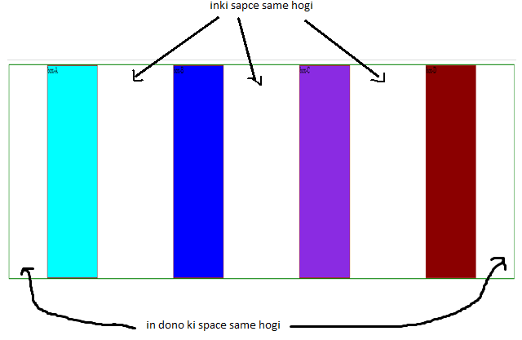

Css

.container{

    border: 1px solid green;

    height: 400px;

    display: flex;

    flex-wrap: wrap;

   justify-content: space-evenly;

}

.box{

    border:1px solid brown;

    width: 200px;

}

#boxA{

    background-color: cyan;

}

#boxB{

    background-color:blue;

}

#boxC{

    background-color:blueviolet;

}

#boxD{

    background-color:darkred;

}

Output

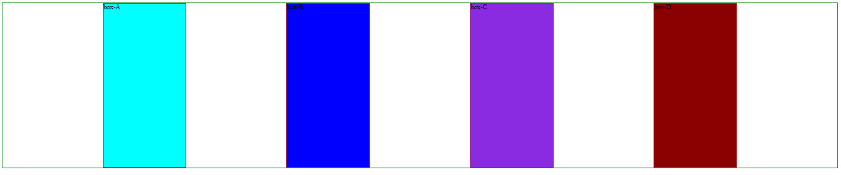

Note : evenly mai sabki space same hogi

Css

.container{

    border: 1px solid green;

    height: 400px;

    display: flex;

    flex-wrap: wrap;

   justify-content: space-between;

}

.box{

    border:1px solid brown;

    width: 200px;

}

#boxA{

    background-color: cyan;

}

#boxB{

    background-color:blue;

}

#boxC{

    background-color:blueviolet;

}

#boxD{

    background-color:darkred;

}

Output

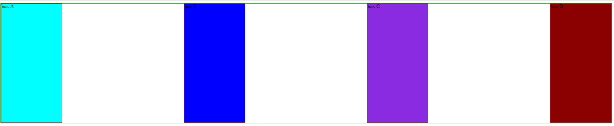

Css

.container{

    border: 1px solid green;

    height: 400px;

    display: flex;

    flex-wrap: wrap;

   justify-content: space-between;

   align-items: flex-start;

}

.box{

    border:1px solid brown;

    width: 200px;

}

#boxA{

    background-color: cyan;

}

#boxB{

    background-color:blue;

}

#boxC{

    background-color:blueviolet;

}

#boxD{

    background-color:darkred;

}

Output

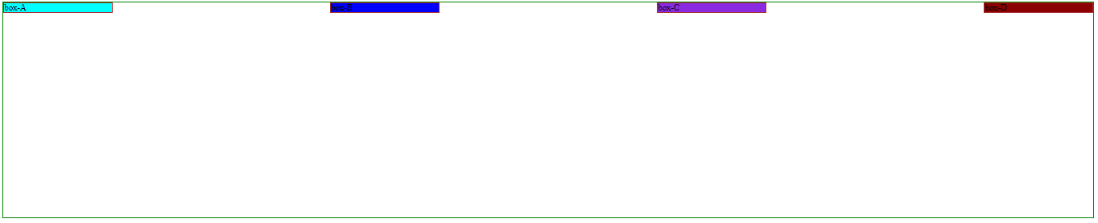

Note : align-items mai cross axis ke uppar properties alignment hoti hai…

Css

.container{

    border: 1px solid green;

    height: 400px;

    display: flex;

    flex-wrap: wrap;

   justify-content: space-between;

   align-items: flex-end;

}

.box{

    border:1px solid brown;

    width: 200px;

}

#boxA{

    background-color: cyan;

}

#boxB{

    background-color:blue;

}

#boxC{

    background-color:blueviolet;

}

#boxD{

    background-color:darkred;

}

Output

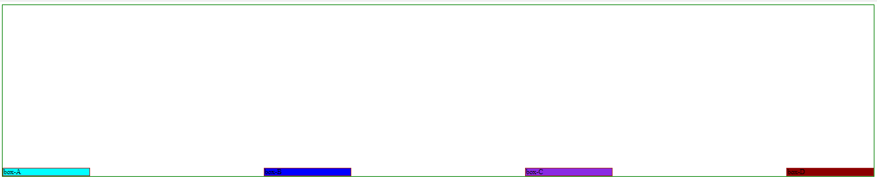

Css

.container{

    border: 1px solid green;

    height: 400px;

    display: flex;

    flex-wrap: wrap;

   justify-content: space-between;

   align-items: center;

}

.box{

    border:1px solid brown;

    width: 200px;

}

#boxA{

    background-color: cyan;

}

#boxB{

    background-color:blue;

}

#boxC{

    background-color:blueviolet;

}

#boxD{

    background-color:darkred;

}

Output

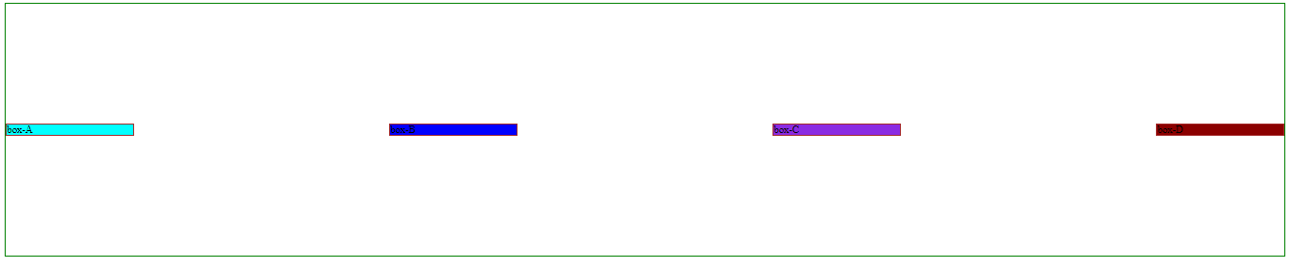

Css

.container{

    border: 1px solid green;

    height: 400px;

    display: flex;

    flex-wrap: wrap;

   justify-content: space-between;

   align-items: stretch;

}

.box{

    border:1px solid brown;

    width: 200px;

}

#boxA{

    background-color: cyan;

}

#boxB{

    background-color:blue;

}

#boxC{

    background-color:blueviolet;

}

#boxD{

    background-color:darkred;

}

Output

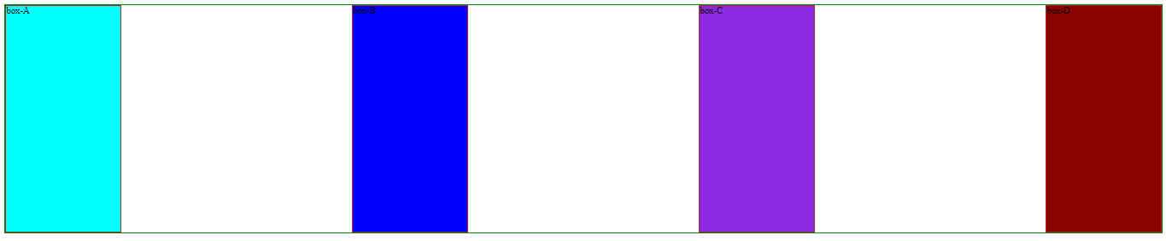

Note :align-items ki by default value stretch hoti hai..

Html

<!DOCTYPE html>

<html lang="en">

<head>

    <meta charset="UTF-8">

    <meta http-equiv="X-UA-Compatible" content="IE=edge">

    <meta name="viewport" content="width=device-width, initial-scale=1.0">

    <title>Document</title>

    <link rel="stylesheet" href="/addStyle/html3_2.css">

</head>

<body>

    <div class="container">

        <div class="box" id="boxA"><h1>boxA</h1></div>

        <div class="box" id="boxB"><h3>boxB</h3></div>

        <div class="box" id="boxC"><h2>boxC</h2></div>

        <div class="box" id="boxD"><h4>boxD</h4></div>

    </div>

</body>

</html>

Css

.container{

    border: 1px solid green;

    height: 400px;

    display: flex;

    flex-wrap: wrap;

   justify-content: space-between;

  align-items: baseline;

}

.box{

    border:1px solid brown;

    width: 200px;

}

#boxA{

    background-color: cyan;

}

#boxB{

    background-color:blue;

}

#boxC{

    background-color:blueviolet;

}

#boxD{

    background-color:darkred;

}

Output

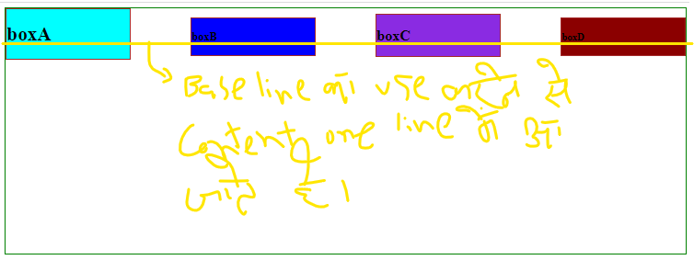

Html

<!DOCTYPE html>

<html lang="en">

<head>

    <meta charset="UTF-8">

    <meta http-equiv="X-UA-Compatible" content="IE=edge">

    <meta name="viewport" content="width=device-width, initial-scale=1.0">

    <title>Document</title>

    <link rel="stylesheet" href="/addStyle/html3_2.css">

</head>

<body>

    <div class="container">

        <div class="box" id="boxA">boxA</div>

        <div class="box" id="boxB">boxB</div>

        <div class="box" id="boxC">boxC</div>

        <div class="box" id="boxD">boxD</div>

    </div>

</body>

</html>

Css

.container{

    border: 1px solid green;

    height: 400px;

    display: flex;

    flex-wrap: wrap;

    justify-content: center;

}

.box{

    border:1px solid brown;

    width: 200px;

}

#boxA{

    background-color: cyan;

}

#boxB{

    background-color:blue;

}

#boxC{

    background-color:blueviolet;

}

#boxD{

    background-color:darkred;

}

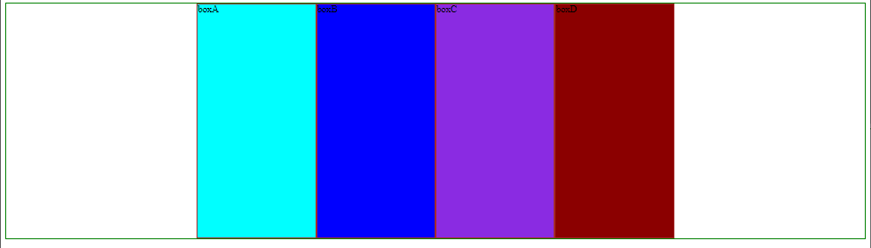

Css part

.container{

    border: 1px solid green;

    height: 400px;

    display: flex;

    flex-wrap: wrap;

   justify-content: center;

    align-items: center;

    gap: 10px;

}

.box{

    border:1px solid brown;

    width: 200px;

}

#boxA{

    background-color: cyan;

}

#boxB{

    background-color:blue;

}

#boxC{

    background-color:blueviolet;

}

#boxD{

    background-color:darkred;

}

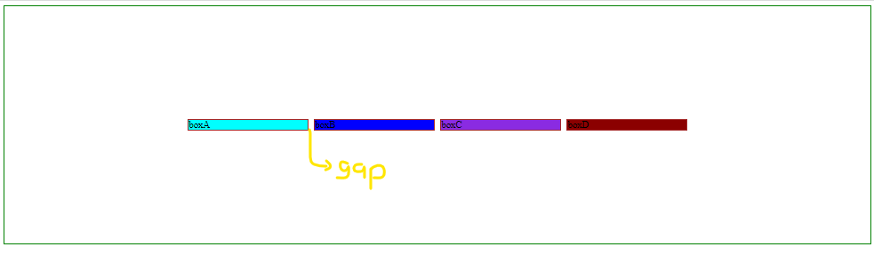

Css

.container{

    border: 1px solid green;

    height: 400px;

    display: flex;

    flex-wrap: wrap;

    justify-content: center;

    align-items: center;

    align-content: flex-start;

}

.box{

    border:1px solid brown;

    width: 200px;

}

#boxA{

    background-color: cyan;

}

#boxB{

    background-color:blue;

}

#boxC{

    background-color:blueviolet;

}

#boxD{

    background-color:darkred;

}

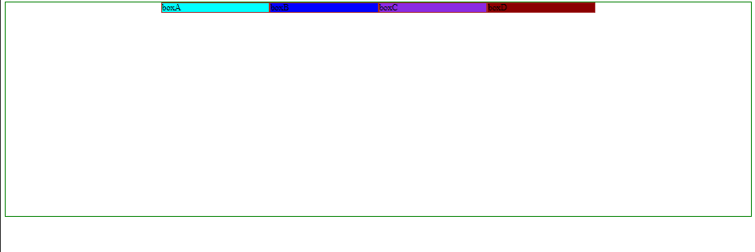

Note : align-content multiple row ke gap mai space ko handle karta hai…

Css

.container{

    border: 1px solid green;

    height: 400px;

    display: flex;

    flex-wrap: wrap;

    justify-content: center;

    align-items: center;

    align-content: flex-end;

}

.box{

    border:1px solid brown;

    width: 200px;

}

#boxA{

    background-color: cyan;

}

#boxB{

    background-color:blue;

}

#boxC{

    background-color:blueviolet;

}

#boxD{

    background-color:darkred;

}

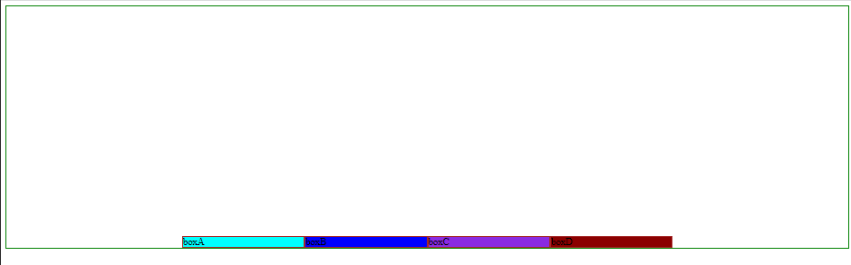

Css

.container{

    border: 1px solid green;

    height: 400px;

    display: flex;

    flex-wrap: wrap;

    justify-content: center;

    align-items: center;

    align-content: flex-start;

}

.box{

    border:1px solid brown;

    width: 200px;

}

#boxA{

    background-color: cyan;

}

#boxB{

    background-color:blue;

}

#boxC{

    background-color:blueviolet;

}

#boxD{

    background-color:darkred;

}

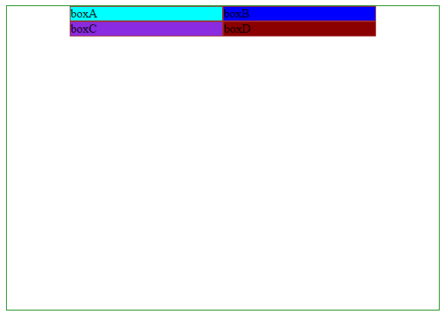

Css

.container{

    border: 1px solid green;

    height: 400px;

    display: flex;

    flex-wrap: wrap;

    justify-content: center;

    align-items: center;

    align-content: flex-end;

}

.box{

    border:1px solid brown;

    width: 200px;

}

#boxA{

    background-color: cyan;

}

#boxB{

    background-color:blue;

}

#boxC{

    background-color:blueviolet;

}

#boxD{

    background-color:darkred;

}

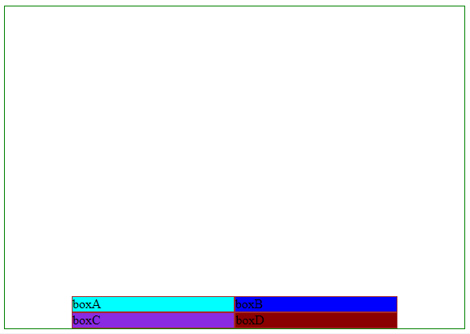

Css

.container{

    border: 1px solid green;

    height: 400px;

    display: flex;

    flex-wrap: wrap;

    justify-content: center;

    align-items: center;

    align-content: space-around;

}

.box{

    border:1px solid brown;

    width: 200px;

}

#boxA{

    background-color: cyan;

}

#boxB{

    background-color:blue;

}

#boxC{

    background-color:blueviolet;

}

#boxD{

    background-color:darkred;

}

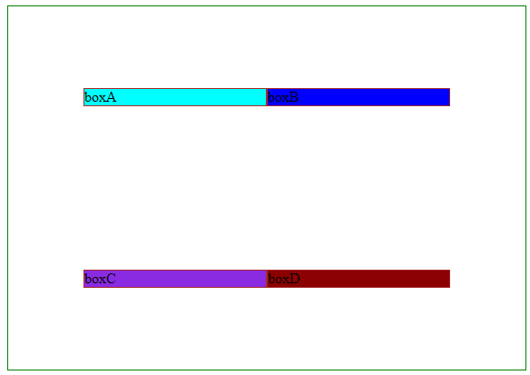

Css

.container{

    border: 1px solid green;

    height: 400px;

    display: flex;

    flex-wrap: wrap;

    justify-content: center;

    align-items: center;

    align-content: space-evenly;

}

.box{

    border:1px solid brown;

    width: 200px;

}

#boxA{

    background-color: cyan;

}

#boxB{

    background-color:blue;

}

#boxC{

    background-color:blueviolet;

}

#boxD{

    background-color:darkred;

}

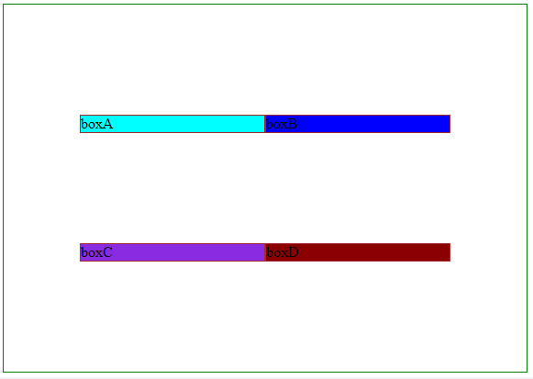

Css

.container{

    border: 1px solid green;

    height: 400px;

    display: flex;

    flex-wrap: wrap;

    justify-content: center;

    align-items: center;

    align-content: space-between;

}

.box{

    border:1px solid brown;

    width: 200px;

}

#boxA{

    background-color: cyan;

}

#boxB{

    background-color:blue;

}

#boxC{

    background-color:blueviolet;

}

#boxD{

    background-color:darkred;

}

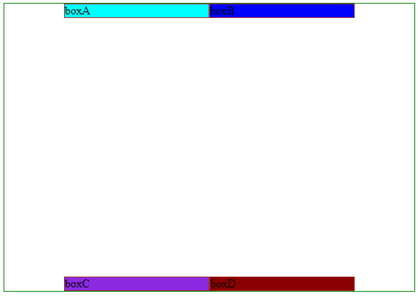

Flex items properties

Order

Html

<!DOCTYPE html>

<html lang="en">

<head>

    <meta charset="UTF-8">

    <meta http-equiv="X-UA-Compatible" content="IE=edge">

    <meta name="viewport" content="width=device-width, initial-scale=1.0">

    <title>Document</title>

    <link rel="stylesheet" href="/addStyle/html3_3.css">

</head>

<body>

    <div class="container">

        <div class="box" id="boxA">boxA</div>

        <div class="box" id="boxB">boxB</div>

        <div class="box" id="boxC">boxC</div>

        <div class="box" id="boxD">boxD</div>

    </div>

</body>

</html>

Css :

.container{

    border: 1px solid green;

    height: 400px;

    display: flex;

    flex-wrap: wrap;

    justify-content: center;

    align-items: start;

    gap: 10px;

}

.box{

   height: 50px;

   width: 50px;

}

#boxA{

    order: 1;

    background-color:chartreuse;

}

#boxC{

    order: 8;

    background-color: blue;

}

#boxB{

    background-color:cyan;

}

#boxD{

    background-color:tomato;

}

Output

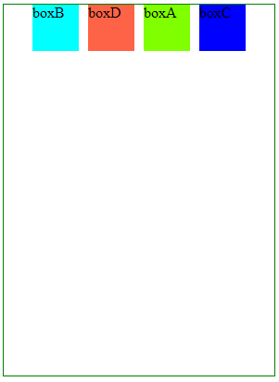

Flex-grow

Html

<!DOCTYPE html>

<html lang="en">

<head>

    <meta charset="UTF-8">

    <meta http-equiv="X-UA-Compatible" content="IE=edge">

    <meta name="viewport" content="width=device-width, initial-scale=1.0">

    <title>Document</title>

    <link rel="stylesheet" href="/addStyle/html3_3.css">

</head>

<body>

    <div class="container">

        <div class="box" id="boxA">boxA</div>

        <div class="box" id="boxB">boxB</div>

        <div class="box" id="boxC">boxC</div>

        <div class="box" id="boxD">boxD</div>

    </div>

</body>

</html>

Css

.container{

    border: 1px solid green;

    height: 400px;

    display: flex;

    flex-wrap: wrap;

    justify-content: center;

    align-items: start;

    gap: 10px;

}

.box{

   height: 50px;

   width: 50px;

   flex-grow: 1;

}

#boxA{

    order: 1;

    background-color:chartreuse;

}

#boxC{

    order: 8;

    background-color: blue;

}

#boxB{

    background-color:cyan;

}

#boxD{

    background-color:tomato;

}

Output

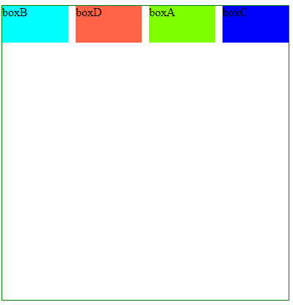

Flex-grow :

Css :

.container{

    border: 1px solid green;

    height: 400px;

    display: flex;

    flex-wrap: wrap;

    justify-content: center;

    align-items: start;

    /* gap: 10px; */

}

.box{

   height: 50px;

   width: 50px;

   flex-grow: 1;

}

#boxA{

    order: 1;

    background-color:chartreuse;

}

#boxC{

    order: 8;

    background-color: blue;

}

#boxB{

    background-color:cyan;

}

#boxD{

    background-color:tomato;

}

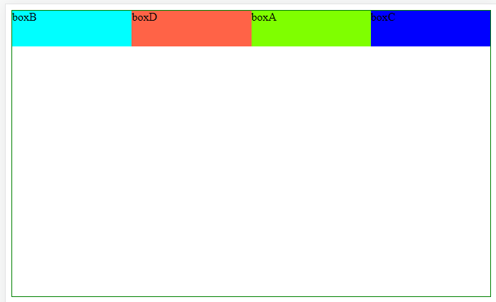

Note : flex-grow ka use karne se div equal width lega..

Html code part same

.container{

    border: 1px solid green;

    height: 400px;

    display: flex;

    flex-wrap: wrap;

    justify-content: center;

    align-items: start;

    gap: 10px;

}

.box{

   height: 50px;

   width: 50px;

}

#boxA{

    order: 1;

    background-color:chartreuse;

    flex-grow: 1;

}

#boxC{

    order: 8;

    background-color: blue;

}

#boxB{

    background-color:cyan;

}

#boxD{

    background-color:tomato;

}

Output

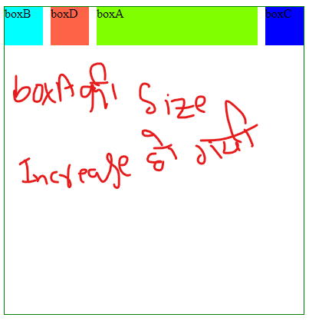

Flex-shrink

Css

.container{

    border: 1px solid green;

    height: 400px;

    display: flex;

    /* flex-wrap: wrap; */

    justify-content: center;

    align-items: start;

    gap: 10px;

}

.box{

   height: 50px;

   width: 100px;

}

#boxA{

    flex-shrink: 4;

    order: 1;

    background-color:chartreuse;

}

#boxC{

    order: 8;

    background-color: blue;

}

#boxB{

    flex-shrink: 1;

    background-color:cyan;

}

#boxD{

    background-color:tomato;

}

Output

Note :by default flex – shrink ki value 1 hoti hai

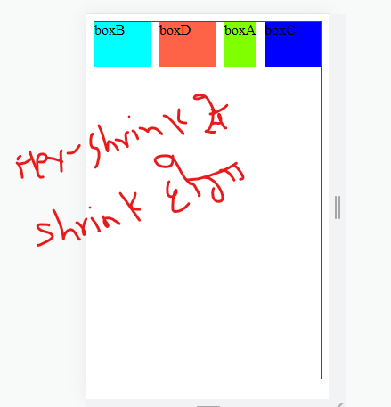

flex-basis

iska use karne se content ke hisaab se increase hoga

Html

<!DOCTYPE html>

<html lang="en">

<head>

    <meta charset="UTF-8">

    <meta http-equiv="X-UA-Compatible" content="IE=edge">

    <meta name="viewport" content="width=device-width, initial-scale=1.0">

    <title>Document</title>

    <link rel="stylesheet" href="/addStyle/html3_3.css">

</head>

<body>

    <div class="container">

        <div class="box" id="boxA">boxA-jdjasljdlsjdljsjdsjdj</div>

        <div class="box" id="boxB">boxB</div>

        <div class="box" id="boxC">boxC</div>

        <div class="box" id="boxD">boxD</div>

    </div>

</body>

</html>

Css

.container{

    border: 1px solid green;

    height: 400px;

    display: flex;

    flex-wrap: wrap;

    justify-content: center;

    align-items: start;

    gap: 10px;

}

.box{

   height: 50px;

   /* width: 100px; */

   flex-basis: 100px;

}

#boxA{

    /* flex-shrink: 4; */

    order: 1;

    background-color:chartreuse;

}

#boxC{

    order: 8;

    background-color: blue;

}

#boxB{

    /* flex-shrink: 1; */

    background-color:cyan;

}

#boxD{

    background-color:tomato;

}

Output :

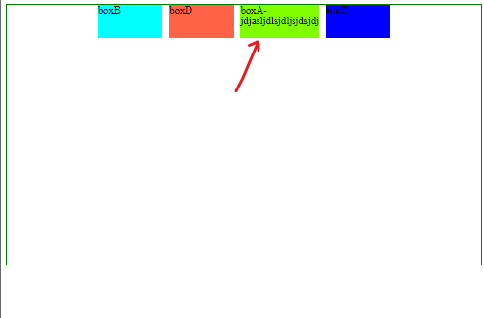

align-self

<!DOCTYPE html>

<html lang="en">

<head>

    <meta charset="UTF-8">

    <meta http-equiv="X-UA-Compatible" content="IE=edge">

    <meta name="viewport" content="width=device-width, initial-scale=1.0">

    <title>Document</title>

    <link rel="stylesheet" href="/addStyle/html3_3.css">

</head>

<body>

    <div class="container">

        <div class="box" id="boxA">boxA</div>

        <div class="box" id="boxB">boxB</div>

        <div class="box" id="boxC">boxC</div>

        <div class="box" id="boxD">boxD</div>

    </div>

</body>

</html>

Css

.container{

    border: 1px solid green;

    height: 400px;

    display: flex;

    flex-wrap: wrap;

    justify-content: center;

    align-items: start;

    gap: 10px;

}

.box{

   /* height: 50px; */

   width: 100px;

}

#boxA{

    /* flex-shrink: 4; */

    order: 1;

    background-color:chartreuse;

}

#boxC{

    align-self: self-end;

    order: 8;

    background-color: blue;

}

#boxB{

    align-self: stretch;

    background-color:cyan;

}

#boxD{

    background-color:tomato;

}

Output

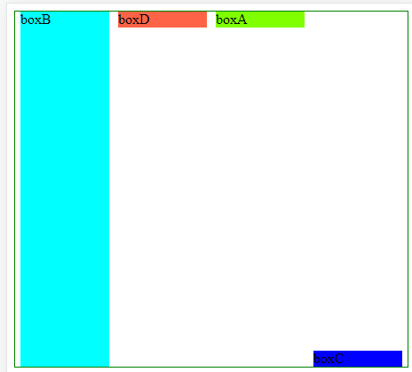

Html

<!DOCTYPE html>

<html lang="en">

<head>

    <meta charset="UTF-8">

    <meta http-equiv="X-UA-Compatible" content="IE=edge">

    <meta name="viewport" content="width=device-width, initial-scale=1.0">

    <title>Document</title>

    <link rel="stylesheet" href="/addStyle/html3_3.css">

</head>

<body>

    <div class="container">

        <div class="box" id="boxA">boxA</div>

        <div class="box" id="boxB">boxB</div>

        <div class="box" id="boxC">boxC</div>

        <div class="box" id="boxD">boxD</div>

    </div>

</body>

</html>

Css

*{

    margin: 0;

    padding: 0;

    box-sizing: border-box;

}

.container{

    border: 2px solid green;

    height: 400px;

    display: flex;

    flex-wrap: wrap;

    justify-content: center;

    align-items: start;

    /* gap: 10px; */

}

.box{

   /* height: 50px; */

   width: 150px;

   flex-basis: 50%;

}

#boxA{

    /* flex-shrink: 4; */

    order: 1;

    background-color:chartreuse;

}

#boxC{

    /* align-self: self-end; */

    order: 8;

    background-color: blue;

}

#boxB{

    /* align-self: stretch; */

    background-color:cyan;

}

#boxD{

    background-color:tomato;

}

Output

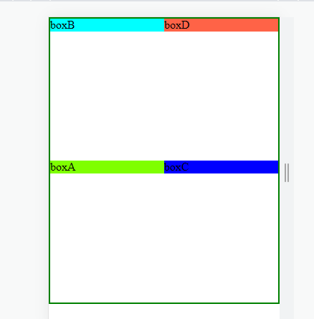

CSS 3D Transform

<!DOCTYPE html>

<html lang="en">

<head>

    <meta charset="UTF-8">

    <meta http-equiv="X-UA-Compatible" content="IE=edge">

    <meta name="viewport" content="width=device-width, initial-scale=1.0">

    <title>Document</title>

    <link rel="stylesheet" href="/addStyle//html3_4.css">

</head>

<body>

    <div class="div"></div>

<div class="div" id="translated"></div>

    <div class="div" id="scaled"></div>

</body>

</html>

Css

.div{

    border: 1px solid black;;

    background-color: aqua;

    width: 100px;

    height: 100px;

}

#translated{

    transform: perspective(15px) translateZ(-15px);

}

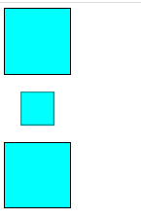

Note : perspective working z-axis aur hamare eye se leker screen ke beech ka jo distance hai usmai 10px de diya hai .

TranslatedZ(-15px) andar hogi ya bahar hogi

<!DOCTYPE html>

<html lang="en">

<head>

    <meta charset="UTF-8">

    <meta http-equiv="X-UA-Compatible" content="IE=edge">

    <meta name="viewport" content="width=device-width, initial-scale=1.0">

    <title>Document</title>

    <link rel="stylesheet" href="/addStyle//html3_4.css">

</head>

<body>

    <div class="div"></div>

    <div class="div" id="translated"></div>

    <div class="div" id="scaled"></div>

</body>

</html>

Css

.div{

    border: 1px solid black;;

    background-color: aqua;

    width: 100px;

    height: 100px;

}

#translated{

    transform: perspective(15px) translateZ(-15px);

}

#scaled{

    margin-left: 200px;

    transform: perspective(15px) scaleZ(1) rotateX(0deg) rotateY(7deg);

}

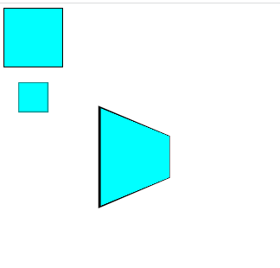

CSS -2D transforms

1.Translate

Html

<!DOCTYPE html>

<html lang="en">

<head>

    <meta charset="UTF-8">

    <meta http-equiv="X-UA-Compatible" content="IE=edge">

    <meta name="viewport" content="width=device-width, initial-scale=1.0">

    <title>Document</title>

    <link rel="stylesheet" href="/addStyle//html4.css">

</head>

<body>

    <div class="box1">box1</div>

</body>

</html>

Css

.box1{

    background-color: aqua;

    height: 200px;

    width: 200px;

    transform: translate(150px,300px);

}

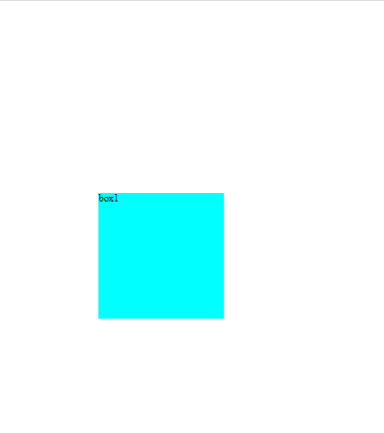

2.Rotate

.box1{

    background-color: aqua;

    border: 1px solid black;

    height: 100px;

    transform: translate(0,300px);

    transform: rotate(145deg);

}

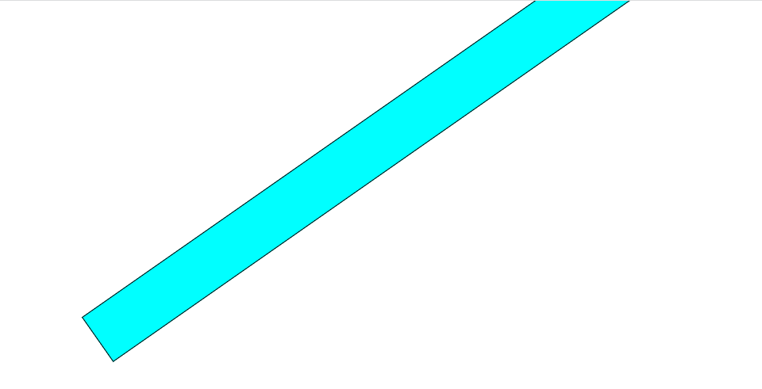

3.scale

.box1{

    background-color: aqua;

    border: 1px solid black;

    height: 100px;

    margin: 200px;

    transform: scale(1,4);

}

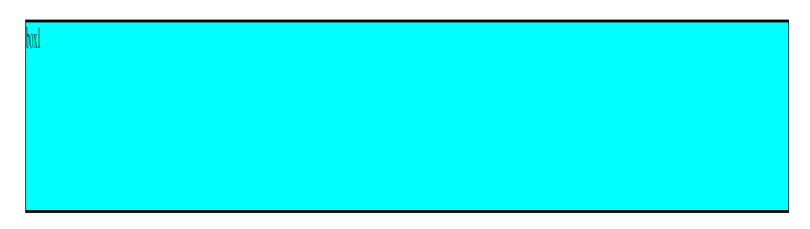

4.skew

.box1{

    background-color: aqua;

    border: 1px solid black;

    height: 100px;

    margin: 200px;

    transform: skew(45deg)

}

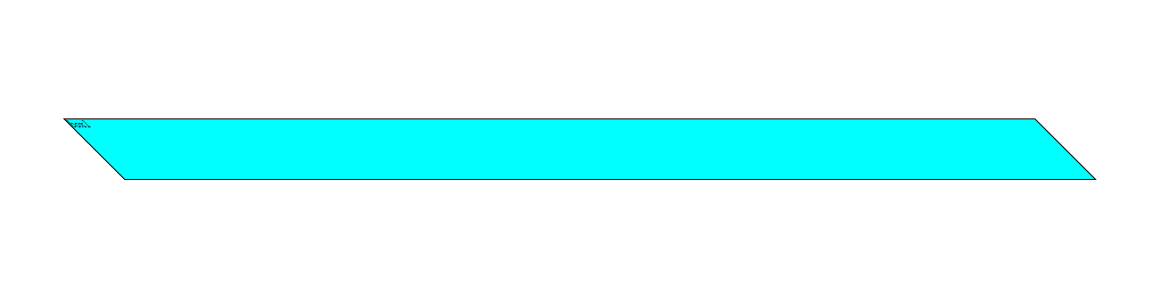

CSS BASICS -IV

Grid

Html

<!DOCTYPE html>

<html lang="en">

<head>

    <meta charset="UTF-8">

    <meta http-equiv="X-UA-Compatible" content="IE=edge">

    <meta name="viewport" content="width=device-width, initial-scale=1.0">

    <title>grid</title>

    <link rel="stylesheet" href="/Html/html2.css">

</head>

<body>

    <div class="container">

        <div class="box">box1</div>

        <div class="box">box2</div>

        <div class="box">box3</div>

        <div class="box">box4</div>

        <div class="box">box5</div>

    </div>

</body>

</html>

Css

*{

    margin: 0;

    padding: 0;

    box-sizing: border-box;

}

.container{

    background-color: brown;

    height: 500px;

    border: 3px solid black;

    display: grid;

}

.box{

    background-color: aqua;

    border: 3px solid black;

    width: 80px;

    height: 80px;

}

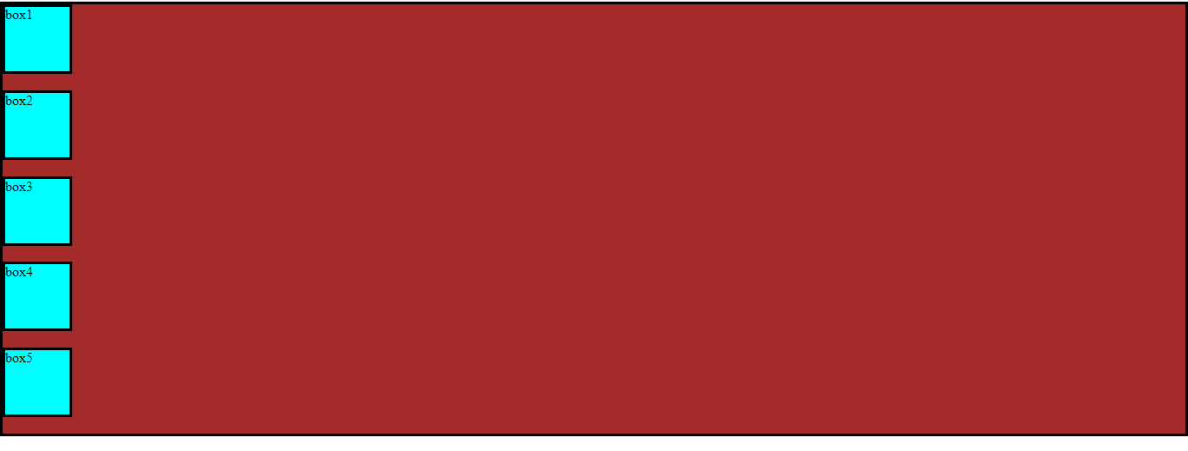

grid-template-columns: 200px 200px 210px;

html part same

css part

*{

    margin: 0;

    padding: 0;

    box-sizing: border-box;

}

.container{

    background-color: brown;

    height: 500px;

    border: 3px solid black;

    display: grid;

    grid-template-columns: 200px 200px 210px;

}

.box{

    background-color: aqua;

    border: 3px solid black;

    width: 80px;

    height: 80px;

}

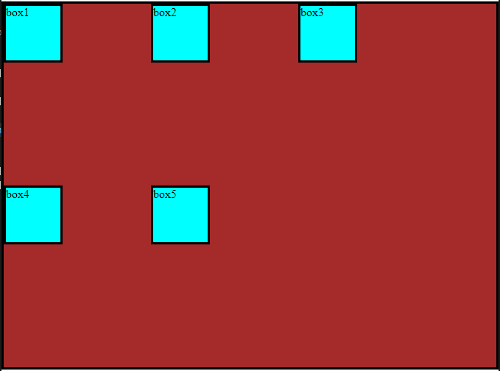

Css

*{

    margin: 0;

    padding: 0;

    box-sizing: border-box;

}

.container{

    background-color: brown;

    height: 500px;

    border: 3px solid black;

    display: grid;

    grid-template-columns: 200px 200px 210px;

    grid-template-rows: 90px 90px 90px 90px;

}

.box{

    background-color: aqua;

    border: 3px solid black;

    width: 80px;

    height: 80px;

}

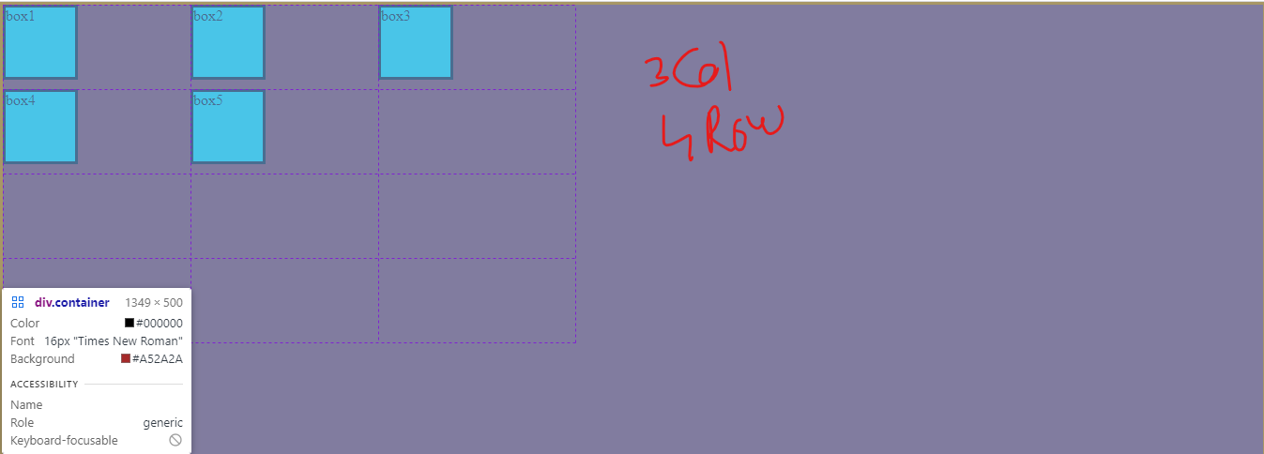

Css

*{

    margin: 0;

    padding: 0;

    box-sizing: border-box;

}

.container{

    background-color: brown;

    height: 500px;

    border: 3px solid black;

    display: grid;

    grid-template-columns: 1fr 1fr 1fr;

    /* Is ko aisa bhi likh sakhte hai same output aayega  grid-template-columns: repeat(3,1fr); */

    grid-template-rows: 90px 90px 90px 90px;

}

.box{

    background-color: aqua;

    border: 3px solid black;

    width: 80px;

    height: 80px;

}

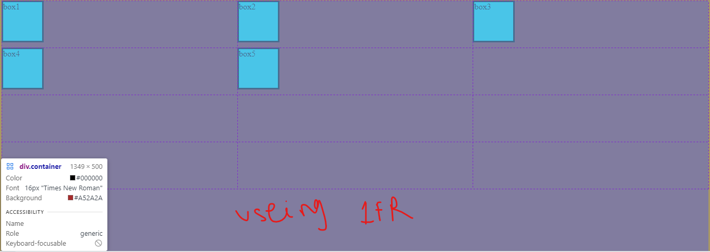

Css

*{

    margin: 0;

    padding: 0;

    box-sizing: border-box;

}

.container{

    background-color: brown;

    height: 500px;

    border: 3px solid black;

    display: grid;

    grid-template-columns: 100px repeat(2,1fr) 200px;

    grid-template-rows: 90px 90px 90px 90px;

}

.box{

    background-color: aqua;

    border: 3px solid black;

    width: 80px;

    height: 80px;

}

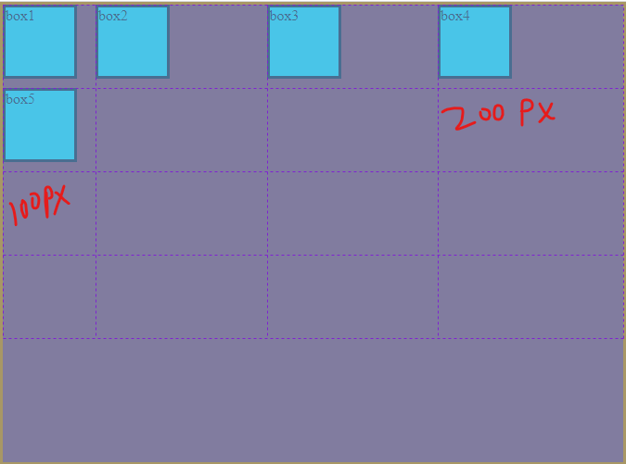

Css

*{

    margin: 0;

    padding: 0;

    box-sizing: border-box;

}

.container{

    background-color: brown;

    height: 500px;

    border: 3px solid black;

    display: grid;

    grid-template-columns: repeat(2,1fr);

    grid-template-rows: repeat(4,1fr);

}

.box{

    background-color: aqua;

    border: 3px solid black;

    width: 80px;

    height: 80px;

}

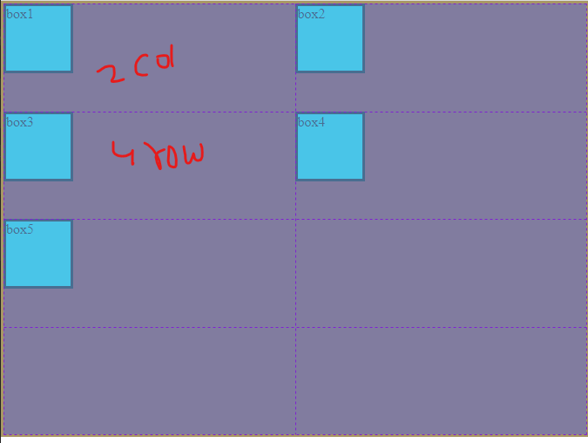

Css

*{

    margin: 0;

    padding: 0;

    box-sizing: border-box;

}

.container{

    background-color: brown;

    height: 500px;

    border: 3px solid black;

    display: grid;

    grid-template-columns: repeat(2,1fr);

    grid-template-rows: repeat(4,1fr);

    gap: 10px;

}

.box{

    background-color: aqua;

    border: 3px solid black;

    width: 80px;

    height: 80px;

}

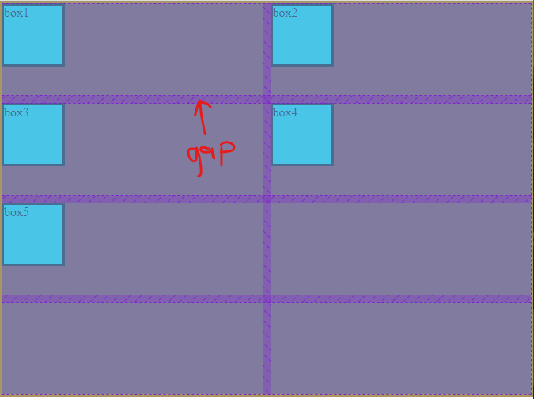

Animations & Responsive

Advanced Grids, Media Queries & Brakpoints

Html

<!DOCTYPE html>

<html lang="en">

<head>

    <meta charset="UTF-8">

    <meta http-equiv="X-UA-Compatible" content="IE=edge">

    <meta name="viewport" content="width=device-width, initial-scale=1.0">

    <title>Document</title>

    <link rel="stylesheet" href="/Html/html3.css">

</head>

<body>

    <div class="container">

        <div class="box" id="box1">box1</div>

        <div class="box">box2</div>

        <div class="box">box3</div>

        <div class="box">box4</div>

        <div class="box">box5</div>

        <div class="box">box6</div>

        <div class="box">box7</div>

        <div class="box">box8</div>

        <div class="box">box9</div>

    </div>

</body>

</html>

Css

.container{

    height: 700px;

    border: 1px solid red;

    background-color: yellow;

    display: grid;

    grid-template-columns: repeat(3,1fr);

    grid-template-rows: repeat(4,1fr);

    grid-gap: 10px;

}

.box{

    border: 1px solid green;

    background-color: aqua;

    /* height: 100px;

    width: 100px;; */

}

#box1{

    grid-column-start: 1;

    grid-column-end: 4;

}

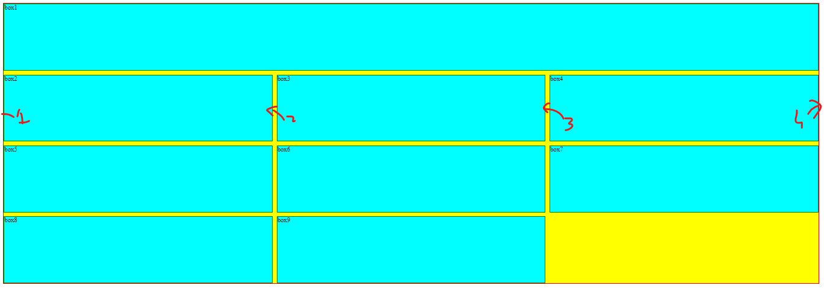

Html part same only change in css part

.container{

    height: 700px;

    border: 1px solid red;

    background-color: yellow;

    display: grid;

    grid-template-columns: repeat(3,1fr);

    grid-template-rows: repeat(4,1fr);

    grid-gap: 10px;

}

.box{

    border: 1px solid green;

    background-color: aqua;

    /* height: 100px;

    width: 100px;; */

}

#box1{

    grid-column-start: 1;

    grid-column-end: 4;

    grid-row-start: 1;

    grid-row-end: 3;

}

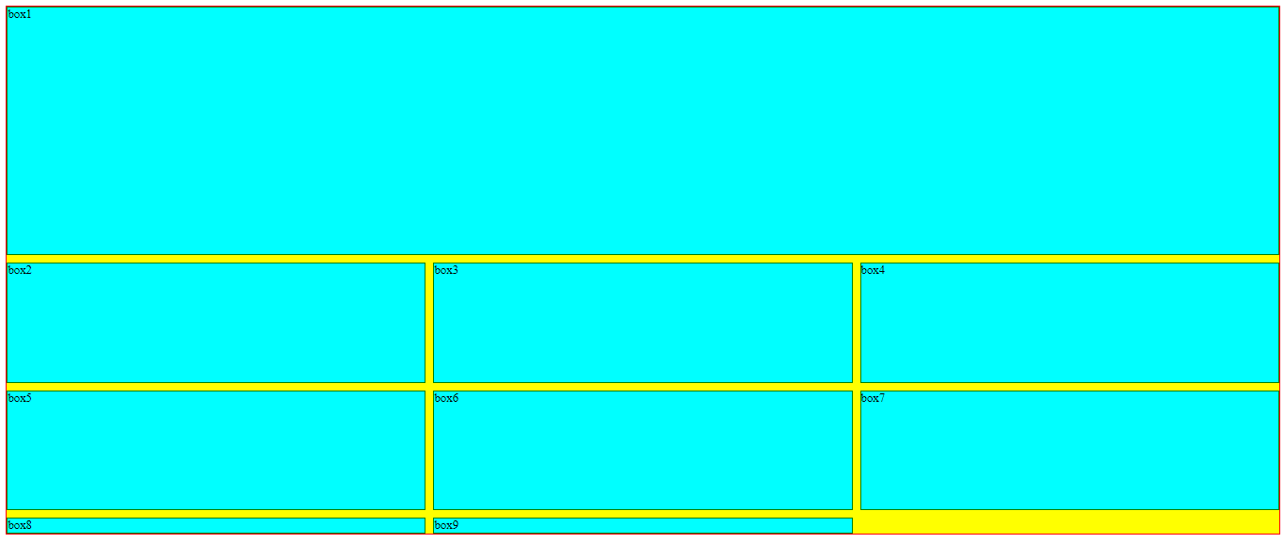

Css

Grid-area

.container{

    height: 700px;

    border: 1px solid red;

    background-color: yellow;

    display: grid;

    grid-template-columns: repeat(3,1fr);

    grid-template-rows: repeat(4,1fr);

    grid-gap: 10px;

}

.box{

    border: 1px solid green;

    background-color: aqua;

    /* height: 100px;

    width: 100px;; */

}

#box1{

    /* grid-column-start: 1;

    grid-column-end: 4;

    grid-row-start: 1;

    grid-row-end: 3; */

    grid-area: 1/1/3/4 ;

}

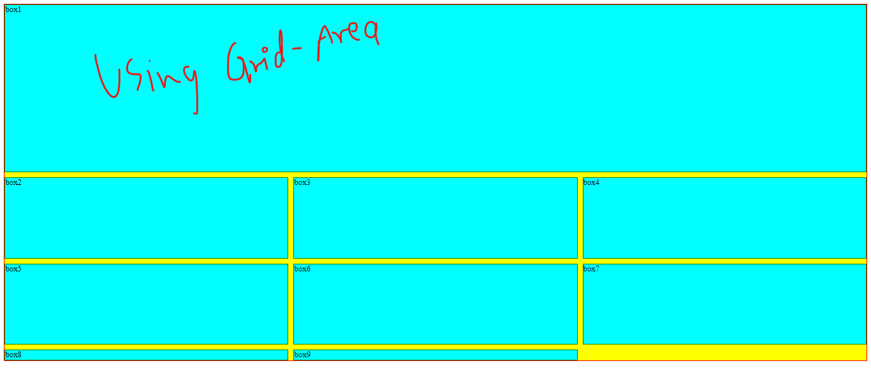

Grid-template-areas

Html

<!DOCTYPE html>

<html lang="en">

<head>

    <meta charset="UTF-8">

    <meta http-equiv="X-UA-Compatible" content="IE=edge">

    <meta name="viewport" content="width=device-width, initial-scale=1.0">

    <title>Document</title>

    <link rel="stylesheet" href="/Html/html4.css">

</head>

<body>

    <div class="container">

        <div class="box" id="header">header</div>

        <div class="box" id="sidebar">sidebar</div>

        <div class="box" id="contents">contents</div>

        <div class="box" id="footer">footer</div>

    </div>

</body>

</html>

Css

.container{

    height: 700px;

    border: 1px solid red;

    background-color: yellow;

    display: grid;

    grid-template-columns: 400px;

    grid-template-rows: 30px 150px 400px 30px;

    grid-template-areas:

    "hd"

    "side"

    "main"

    "ft";

}

.box{

    border: 1px solid green;

    background-color: aqua;

}

#header{

    grid-area: hd;

}

#sidebar{

    grid-area: side;

}

#contents{

    grid-area: main;

}

#footer{

    grid-area: ft;

}

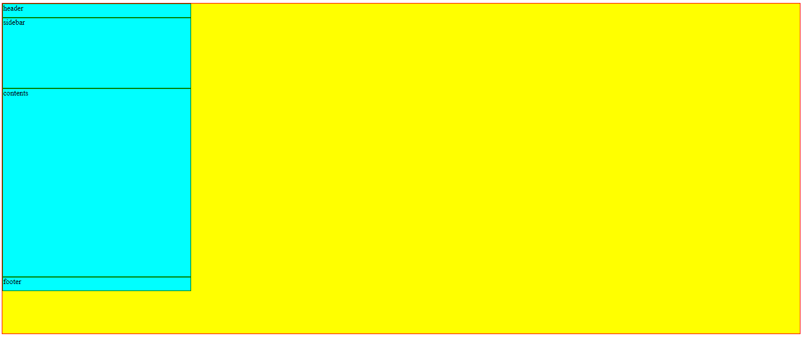

Css

.container{

    height: 700px;

    border: 1px solid red;

    background-color: yellow;

    display: grid;

    grid-template-columns: 200px 400px;

    grid-template-rows: 30px 500px 30px;

    /* grid-template-areas:

    "hd"

    "side"

    "main"

    "ft"; */

    grid-template-areas:

    "hd hd"

    "side main"

    "ft ft";

}

.box{

    border: 1px solid green;

    background-color: aqua;

}

#header{

    grid-area: hd;

}

#sidebar{

    grid-area: side;

}

#contents{

    grid-area: main;

}

#footer{

    grid-area: ft;

}

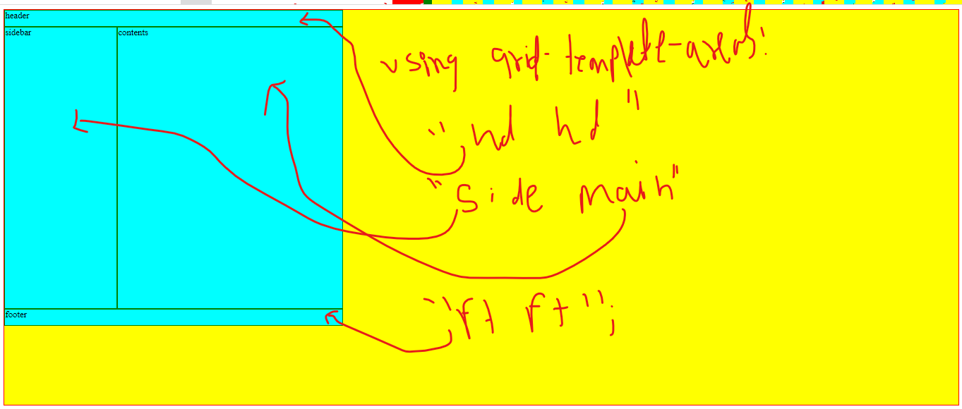

Advanced Grid Concepts

Html

<!DOCTYPE html>

<html lang="en">

<head>

    <meta charset="UTF-8">

    <meta http-equiv="X-UA-Compatible" content="IE=edge">

    <meta name="viewport" content="width=device-width, initial-scale=1.0">

    <title>Document</title>

    <link rel="stylesheet" href="/Html/h5.css">

</head>

<body>

    <div class="container">

        <div class="box">box1</div>

        <div class="box">box2</div>

        <div class="box">box3</div>

        <div class="box">box4</div>

        <div class="box">box5</div>

        <div class="box">box6</div>

        <div class="box">box7</div>

        <div class="box">box8</div>

        <div class="box">box9</div>

        <div class="box">box11</div>

        <div class="box">box12</div>

        <div class="box">box13</div>

        <div class="box">box14</div>

    </div>

</body>

</html>

Css

.container{

    height: 700px;

    border: 1px solid red;

    background-color: yellow;

    display: grid;

    grid-gap: 10px;

    grid-template-columns: repeat(4,1fr);

    grid-auto-rows: minmax(100px,auto);

}

.box{

    border: 1px solid green;

    background-color: aqua;

}

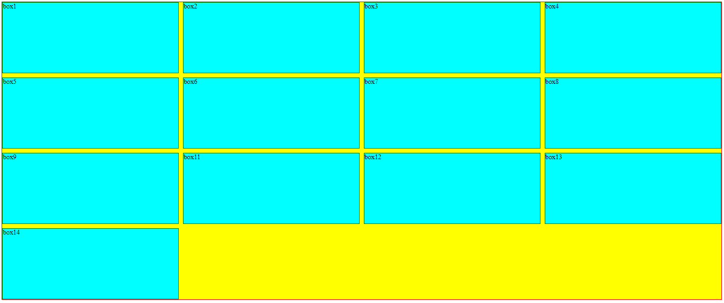

Grid auto rows mai automatic row add hota ,agar content add hota rahega.

Grid-properties

Html

<!DOCTYPE html>

<html lang="en">

<head>

    <meta charset="UTF-8">

    <meta http-equiv="X-UA-Compatible" content="IE=edge">

    <meta name="viewport" content="width=device-width, initial-scale=1.0">

    <title>Document</title>

    <link rel="stylesheet" href="/Html/h5.css">

</head>

<body>

    <div class="container">

        <div class="box">box1</div>

        <div class="box">box2</div>

        <div class="box">box3</div>

        <div class="box">box4</div>

        <div class="box">box5</div>

        <div class="box">box6</div>

        <div class="box">box7</div>

        <div class="box">box8</div>

        <div class="box">box9</div>

        <div class="box">box11</div>

        <div class="box">box12</div>

        <div class="box">box13</div>

        <div class="box">box14</div>

    </div>

</body>

</html>

Css

.container{

    height: 700px;

    border: 1px solid red;

    background-color: yellow;

    display: grid;

    grid-gap: 10px;

    grid-template-columns: 100px 100px 100px;

    grid-template-rows: 100px 100px;

    justify-content: start;

    /* justify-content: end; */

}

.box{

    border: 1px solid green;

    background-color: aqua;

}

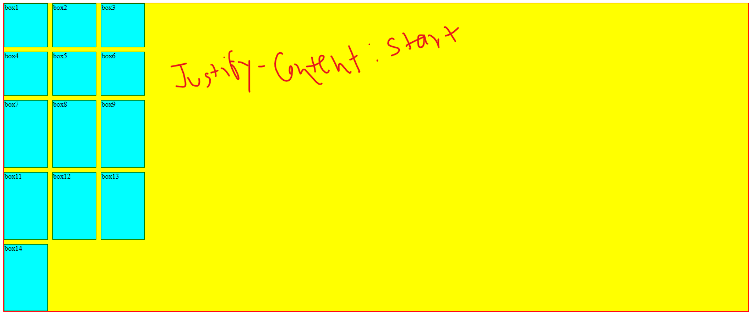

Css (justify-content :end)

.container{

    height: 700px;

    border: 1px solid red;

    background-color: yellow;

    display: grid;

    grid-gap: 10px;

    grid-template-columns: 100px 100px 100px;

    grid-template-rows: 100px 100px;

    /* justify-content: start; */

    justify-content: end;

}

.box{

    border: 1px solid green;

    background-color: aqua;

}

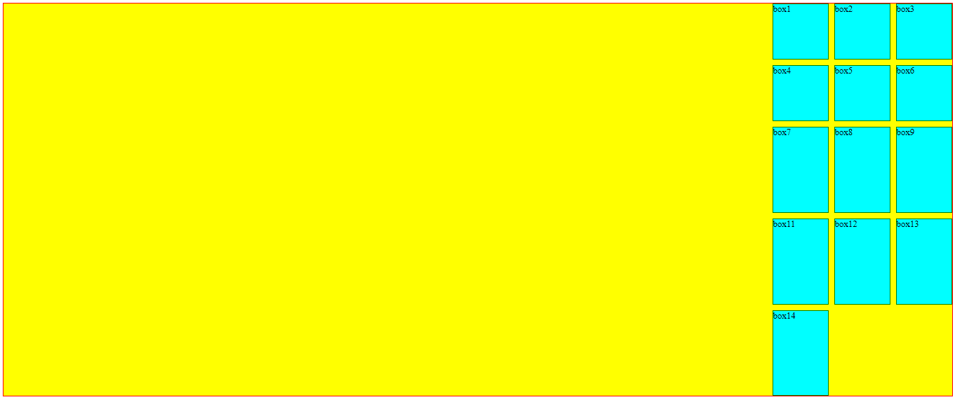

.container{

    height: 700px;

    border: 1px solid red;

    background-color: yellow;

    display: grid;

    grid-gap: 10px;

    grid-template-columns: 100px 100px 100px;

    grid-template-rows: 100px 100px;

    /* justify-content: start; */

    /* justify-content: end; */

    justify-content: center;

}

.box{

    border: 1px solid green;

    background-color: aqua;

}

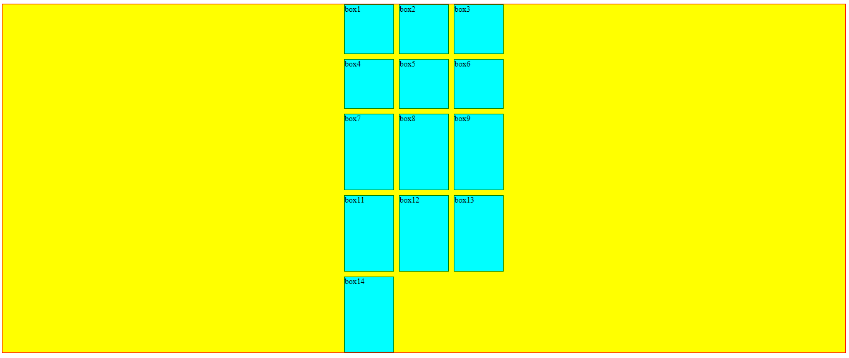

.container{

    height: 700px;

    border: 1px solid red;

    background-color: yellow;

    display: grid;

    grid-gap: 10px;

    grid-template-columns: 100px 100px 100px;

    grid-template-rows: 100px 100px;

    /* justify-content: start; */

    /* justify-content: end; */

    /* justify-content: center; */

    justify-content: space-between;

}

.box{

    border: 1px solid green;

    background-color: aqua;

}

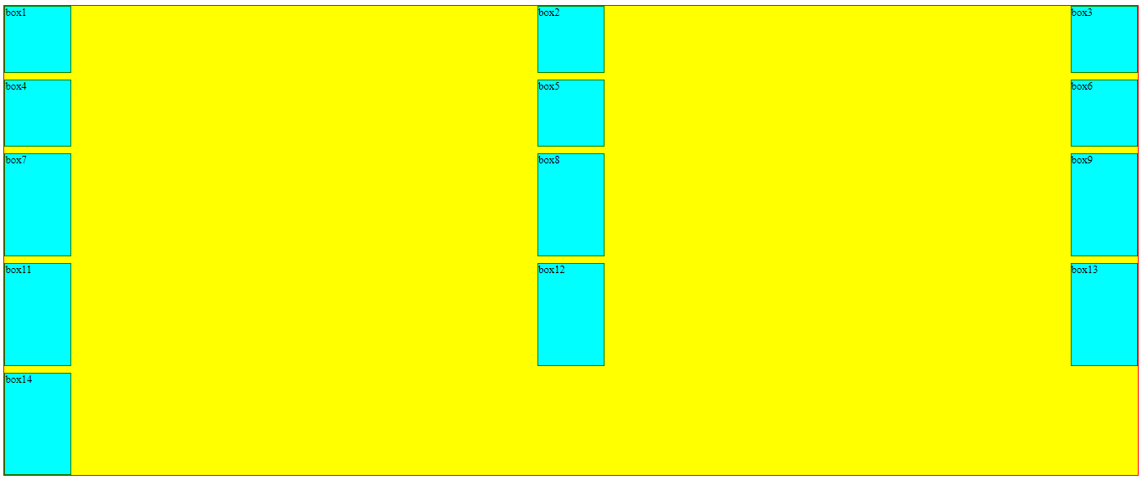

.container{

    height: 700px;

    border: 1px solid red;

    background-color: yellow;

    display: grid;

    grid-gap: 10px;

    grid-template-columns: 100px 100px 100px;

    grid-template-rows: 100px 100px;

    /* justify-content: start; */

    /* justify-content: end; */

    /* justify-content: center; */

    justify-content: space-around;

}

.box{

    border: 1px solid green;

    background-color: aqua;

}

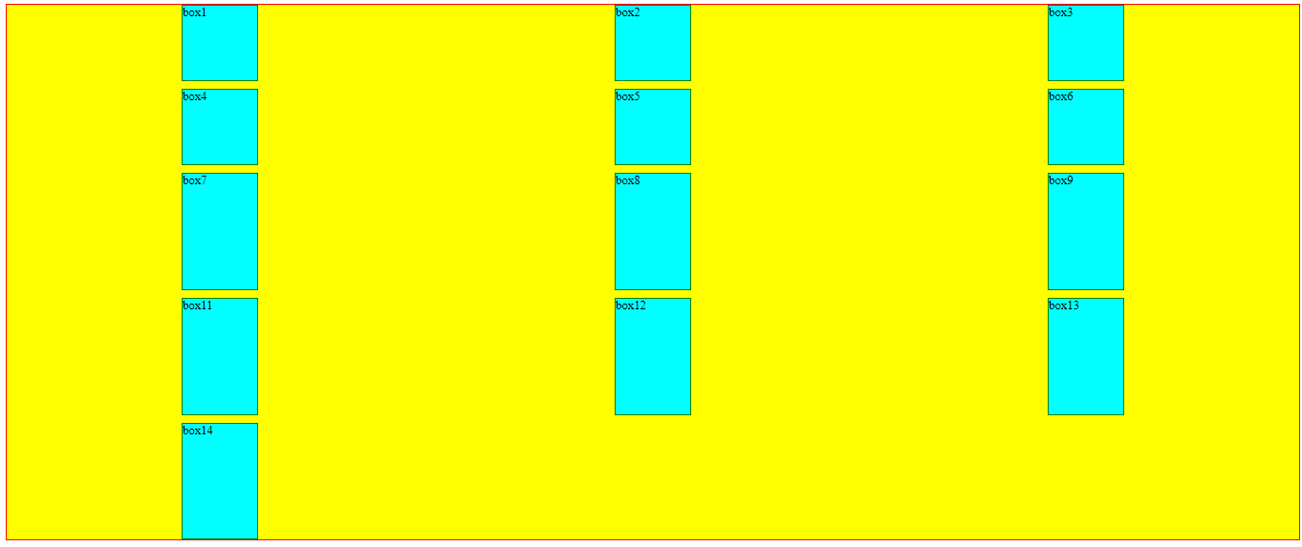

.container{

    height: 700px;

    border: 1px solid red;

    background-color: yellow;

    display: grid;

    grid-gap: 10px;

    grid-template-columns: 100px 100px 100px;

    grid-template-rows: 100px 100px;

    /* justify-content: start; */

    /* justify-content: end; */

    /* justify-content: center; */

    justify-content: space-evenly;

}

.box{

    border: 1px solid green;

    background-color: aqua;

}

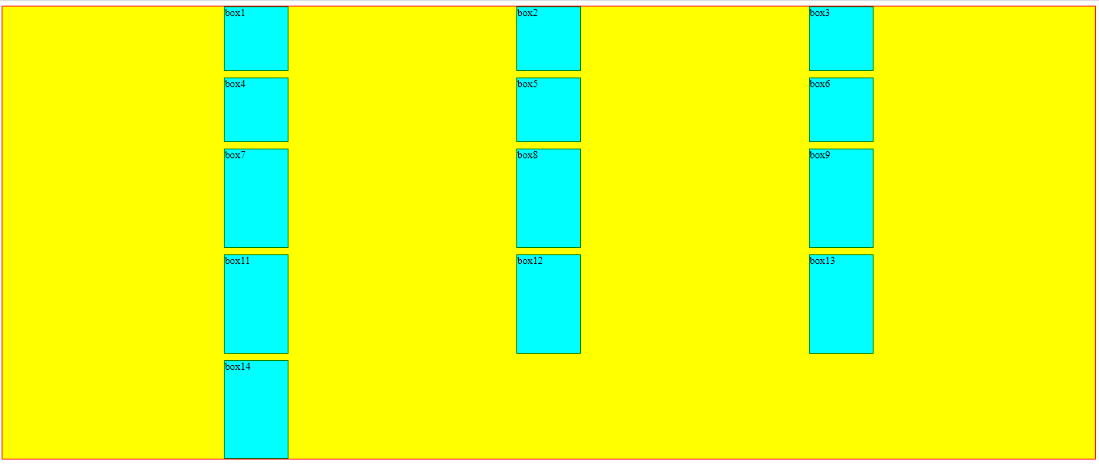

Align-items:start;

.container{

    height: 700px;

    width: 600[x];

    border: 1px solid red;

    background-color: yellow;

    display: grid;

    grid-gap: 10px;

    grid-template-columns: 100px 100px 100px;

    grid-template-rows: 100px 100px;

    align-items: start;

}

.box{

    border: 1px solid green;

    background-color: aqua;

}

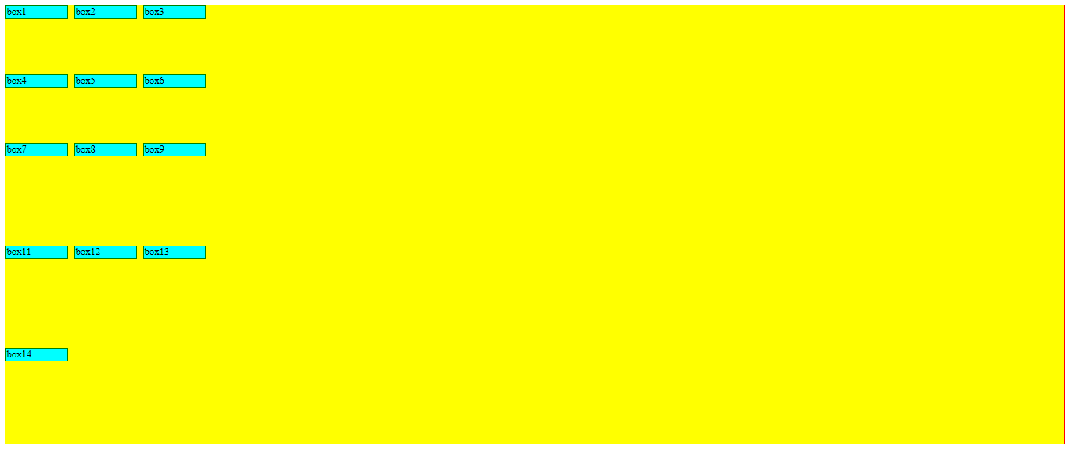

.container{

    height: 700px;

    width: 600px;

    border: 1px solid red;

    background-color: yellow;

    display: grid;

    grid-gap: 10px;

    grid-template-columns: 100px 100px 100px;

    grid-template-rows: 100px 100px;

    align-items: end;

}

.box{

    border: 1px solid green;

    background-color: aqua;

}

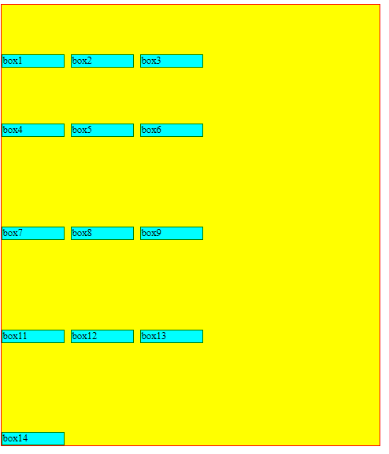

.container{

    height: 700px;

    width: 600px;

    border: 1px solid red;

    background-color: yellow;

    display: grid;

    grid-gap: 10px;

    grid-template-columns: 100px 100px 100px;

    grid-template-rows: 100px 100px;

    align-items: baseline;

}

.box{

    border: 1px solid green;

    background-color: aqua;

}

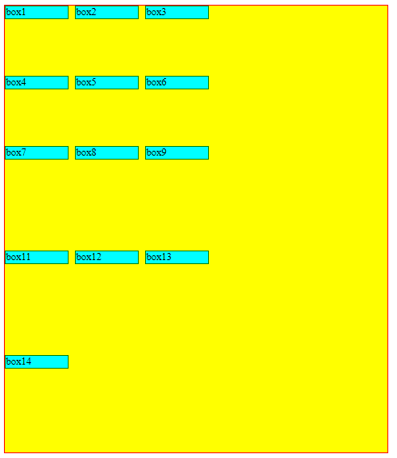

.container{

    height: 700px;

    width: 600px;

    border: 1px solid red;

    background-color: yellow;

    display: grid;

    grid-gap: 10px;

    grid-template-columns: 100px 100px 100px;

    grid-template-rows: 100px 100px;

    align-items: stretch;

}

.box{

    border: 1px solid green;

    background-color: aqua;

}

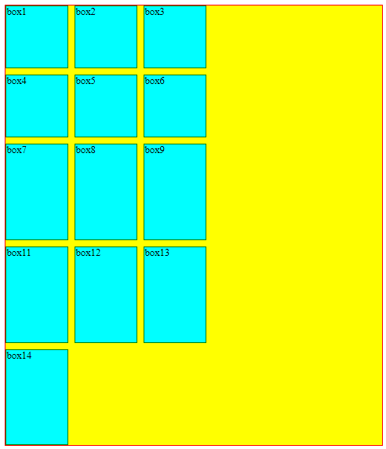

Justify-self:start (jitna content hoga uthna horizontal size lega )

Html:

<!DOCTYPE html>

<html lang="en">

<head>

    <meta charset="UTF-8">

    <meta http-equiv="X-UA-Compatible" content="IE=edge">

    <meta name="viewport" content="width=device-width, initial-scale=1.0">

    <title>Document</title>

    <link rel="stylesheet" href="/Html/h5.css">

</head>

<body>

    <div class="container">

        <div class="box" id="box1">box1</div>

        <div class="box">box2</div>

        <div class="box">box3</div>

        <div class="box">box4</div>

        <div class="box">box5</div>

        <div class="box">box6</div>

        <div class="box">box7</div>

        <div class="box">box8</div>

        <div class="box">box9</div>

        <div class="box">box11</div>

        <div class="box">box12</div>

        <div class="box">box13</div>

        <div class="box">box14</div>

    </div>

</body>

</html>

Css

.container{

    height: 700px;

    width: 600px;

    border: 1px solid red;

    background-color: yellow;

    display: grid;

    grid-gap: 10px;

    grid-template-columns: 100px 100px 100px;

    grid-template-rows: 100px 100px;

    align-items: stretch;

}

.box{

    border: 1px solid green;

    background-color: aqua;

}

#box1{

    justify-self: start;

}

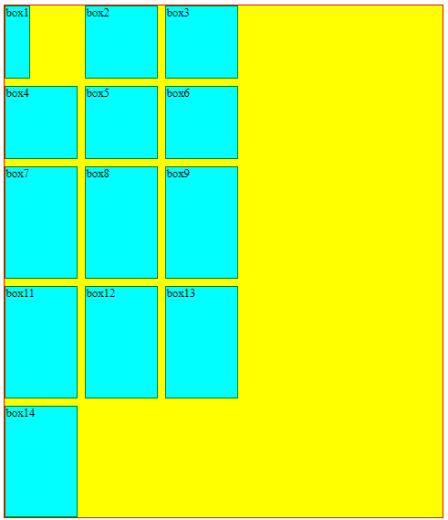

Css

.container{

    height: 700px;

    width: 600px;

    border: 1px solid red;

    background-color: yellow;

    display: grid;

    grid-gap: 10px;

    grid-template-columns: 100px 100px 100px;

    grid-template-rows: 100px 100px;

    align-items: stretch;

}

.box{

    border: 1px solid green;

    background-color: aqua;

}

#box1{

    justify-self: end;

}

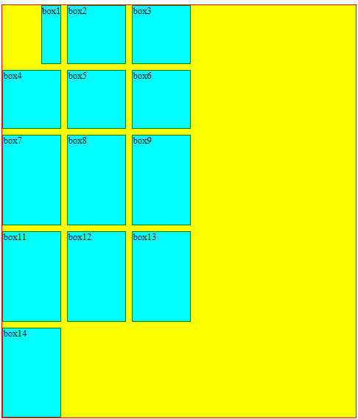

.container{

    height: 700px;

    width: 600px;

    border: 1px solid red;

    background-color: yellow;

    display: grid;

    grid-gap: 10px;

    grid-template-columns: 100px 100px 100px;

    grid-template-rows: 100px 100px;

    align-items: stretch;

}

.box{

    border: 1px solid green;

    background-color: aqua;

}

#box1{

    justify-self: center;

}

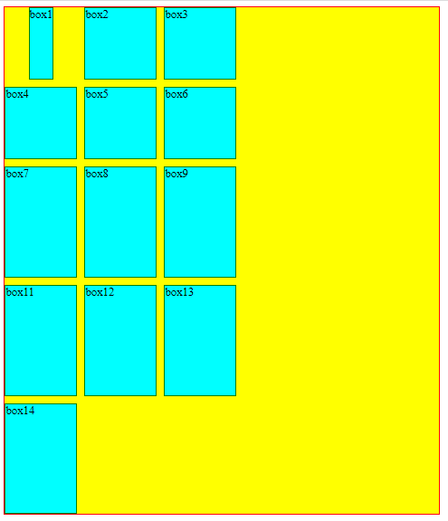

Justify-self child pe lagai jaati hai.

Align-self

.container{

    height: 700px;

    width: 600px;

    border: 1px solid red;

    background-color: yellow;

    display: grid;

    grid-gap: 10px;

    grid-template-columns: 100px 100px 100px;

    grid-template-rows: 100px 100px;

    align-items: stretch;

}

.box{

    border: 1px solid green;

    background-color: aqua;

}

#box1{

    align-self: center;

}

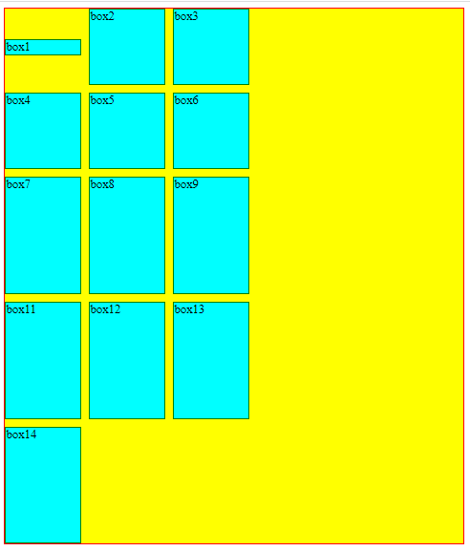

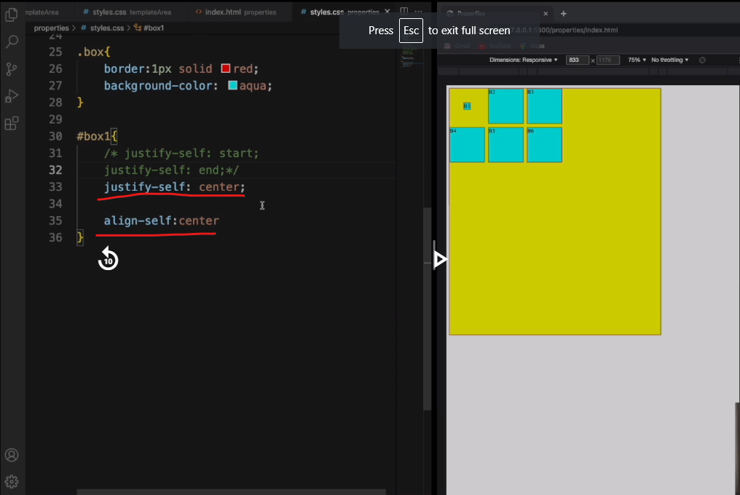

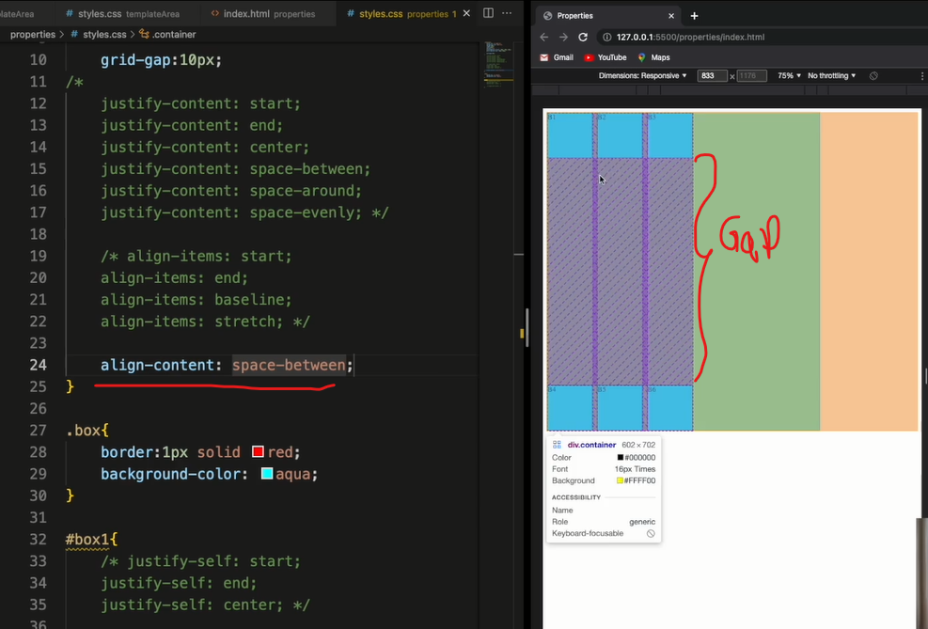

Align-content karne se gap aa gaya

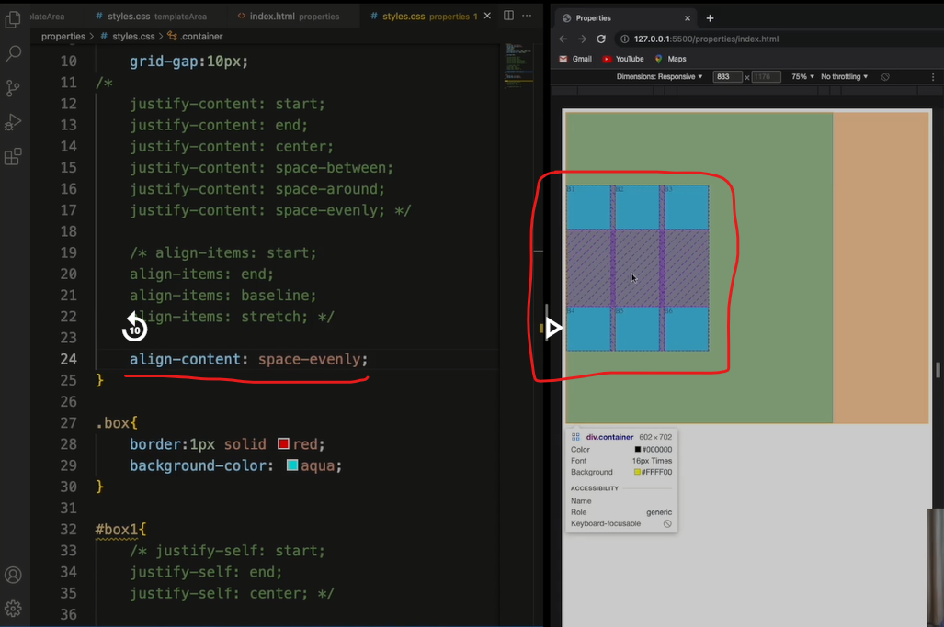

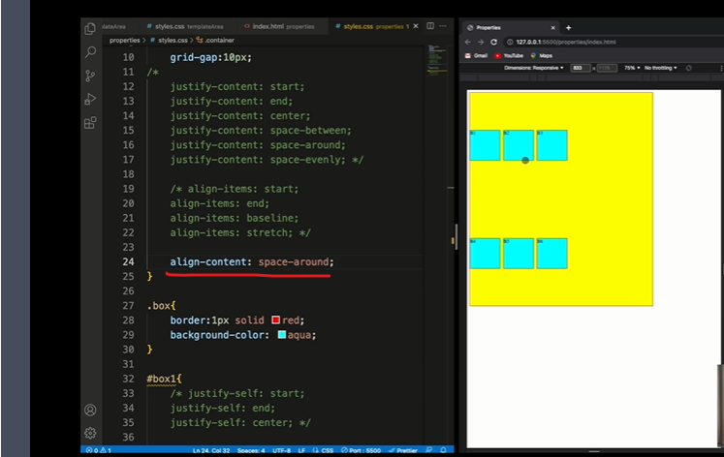

Place-content:center

Html

<!DOCTYPE html>

<html lang="en">

<head>

    <meta charset="UTF-8">

    <meta http-equiv="X-UA-Compatible" content="IE=edge">

    <meta name="viewport" content="width=device-width, initial-scale=1.0">

    <title>Document</title>

    <link rel="stylesheet" href="/Html/h5.css">

</head>

<body>

    <div class="container">

        <div class="box" id="box1">box1</div>

        <div class="box">box2</div>

        <div class="box">box3</div>

        <div class="box">box4</div>

        <div class="box">box5</div>

        <div class="box">box6</div>

    </div>

</body>

</html>

.container{

    height: 700px;

    width: 600px;

    border: 1px solid red;

    background-color: yellow;

    display: grid;

    grid-template-columns: 100px 100px 100px;

    grid-template-rows: 100px 100px;

   place-content: center;

}

.box{

    border: 1px solid green;

    background-color: aqua;

}

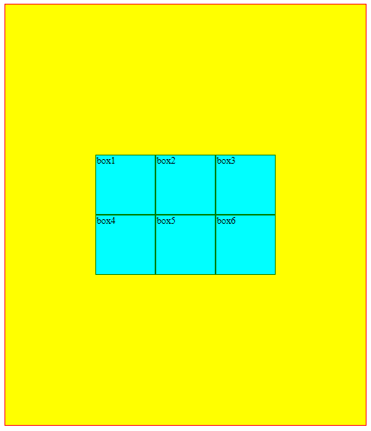

Place –items:center

.container{

    height: 700px;

    width: 600px;

    border: 1px solid red;

    background-color: yellow;

    display: grid;

    grid-template-columns: 100px 100px 100px;

    grid-template-rows: 100px 100px;

   place-items: center;

}

.box{

    border: 1px solid green;

    background-color: aqua;

}

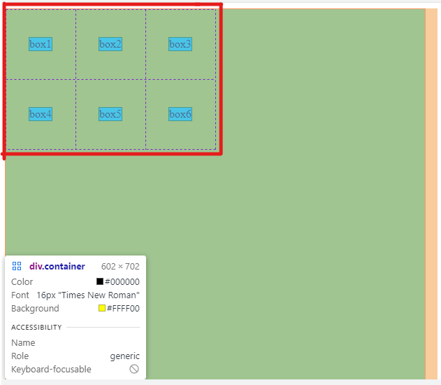

Html

<!DOCTYPE html>

<html lang="en">

<head>

    <meta charset="UTF-8">

    <meta http-equiv="X-UA-Compatible" content="IE=edge">

    <meta name="viewport" content="width=device-width, initial-scale=1.0">

    <title>Document</title>

    <link rel="stylesheet" href="/Html/post.css">

</head>

<body>

    <div class="container">

        <div class="box" id="header">

            <a href="/Html/h6.html">Click here to move forward</a>

        </div>

        <div class="box" id="sidebar">sidebar</div>

        <div class="box" id="content">content</div>

        <div class="box" id="footer">footer</div>

    </div>

</body>

</html>

Css

.container{

    border: 1px solid black;

    background-color: yellow;

    height: 700px;

    display: grid;

    grid-template-rows: 30px 1fr 1fr 30px;

    grid-template-columns: 1fr;

    grid-gap: 4px;

    grid-template-areas:

    "hd "

    "side"

    "main"

    "ft";

}

.box{

    border: 1px solid red;

    background-color: aqua;

}

#header{

    grid-area: hd;

}

#sidebar{

    grid-area: side;

}

#content{

    grid-area: main;

}

#footer{

    grid-area: ft;

}

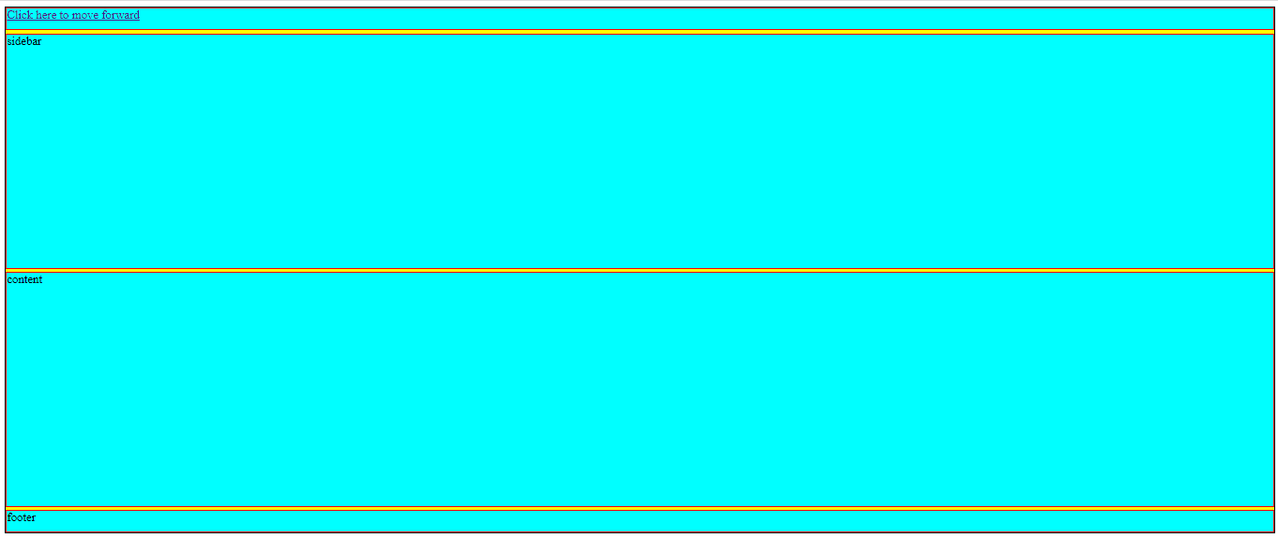

Html

<!DOCTYPE html>

<html lang="en">

<head>

    <meta charset="UTF-8">

    <meta http-equiv="X-UA-Compatible" content="IE=edge">

    <meta name="viewport" content="width=device-width, initial-scale=1.0">

    <title>Document</title>

    <link rel="stylesheet" href="/Html/h6.css">

</head>

<body>

    <div class="container">

        <div class="box" id="header">

            <a href="/Html/post.html">Click here to move forward</a>

        </div>

        <div class="box" id="sidebar">sidebar</div>

        <div class="box" id="content">content</div>

        <div class="box" id="footer">footer</div>

    </div>

</body>

</html>

Css

.container{

    border: 1px solid black;

    background-color: yellow;

    height: 700px;

    display: grid;

    grid-template-rows: 30px 1fr 30px;

    grid-template-columns: 100px 400px;

    grid-gap: 4px;

    grid-template-areas:

    "hd hd"

    "side main"

    "ft ft";

}

.box{

    border: 1px solid red;

    background-color: aqua;

}

#header{

    grid-area: hd;

}

#sidebar{

    grid-area: side;

}

#content{

    grid-area: main;

}

#footer{

    grid-area: ft;

}

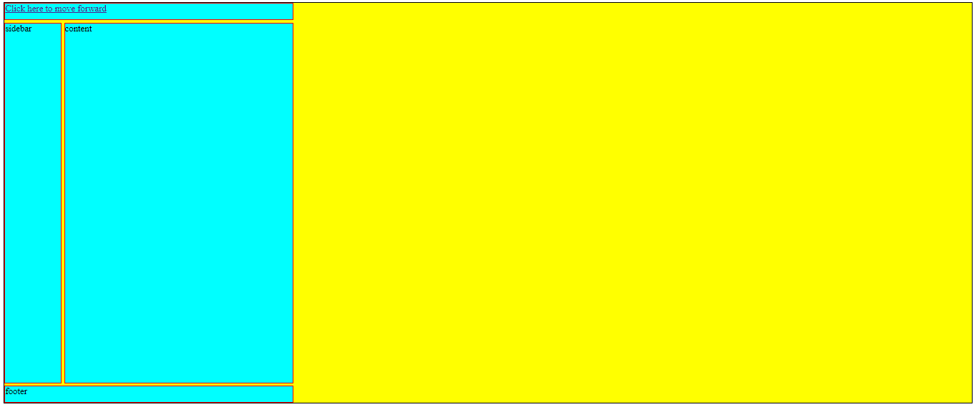

Media-queries

Html

<!DOCTYPE html>

<html lang="en">

<head>

    <meta charset="UTF-8">

    <meta http-equiv="X-UA-Compatible" content="IE=edge">

    <meta name="viewport" content="width=device-width, initial-scale=1.0">

    <title>Document</title>

    <link rel="stylesheet" href="/Html/h7.css">

</head>

<body>

    <div class="container">

        <div class="box" id="header">header</div>

        <div class="box" id="sidebar">sidebar</div>

        <div class="box" id="content">content</div>

        <div class="box" id="footer">footer</div>

    </div>

</body>

</html>

Css

/* *{

    margin: 0px;

    padding: 0px;

    box-sizing: border-box;

} */

.container{

    border: 1px solid black;

    background-color: yellow;

    height: 700px;

    display: grid;

    grid-template-rows: 30px 1fr 30px;

    grid-template-columns: 100px 400px;

    grid-gap: 4px;

    grid-template-areas:

    "hd hd"

    "side main"

    "ft ft";

}

.box{

    border: 1px solid red;

    background-color: aqua;

}

#header{

    grid-area: hd;

}

#sidebar{

    grid-area: side;

}

#content{

    grid-area: main;

}

#footer{

    grid-area: ft;

}

@media(max-width:400px){

    .container{

        grid-gap: 100px;

    }

}

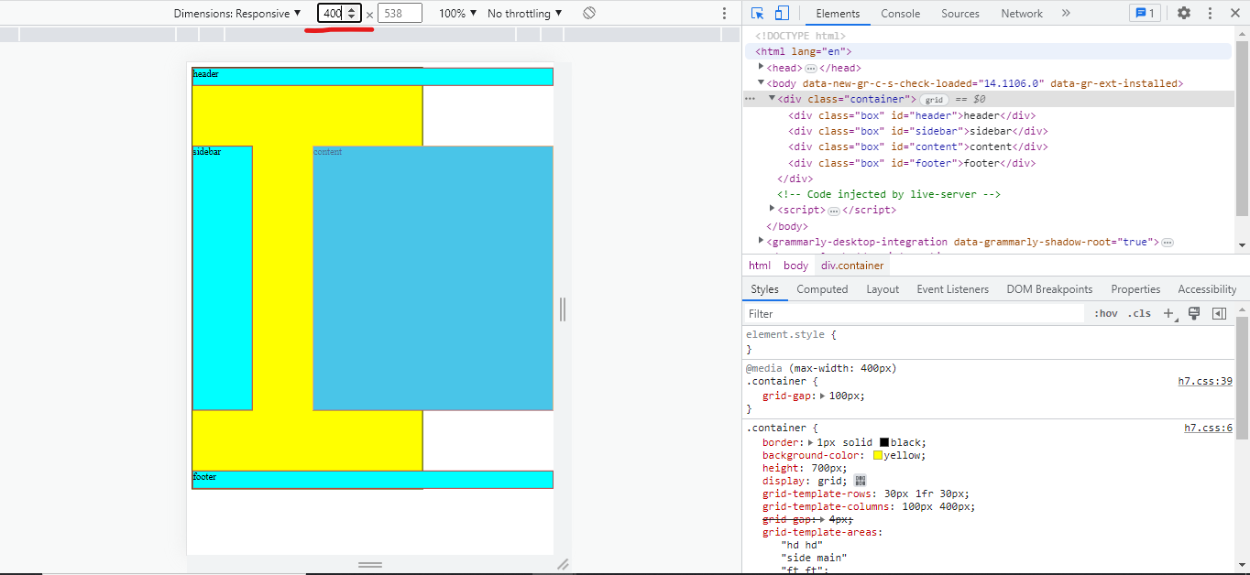

Css

*{

    margin: 0px;

    padding: 0px;

    box-sizing: border-box;

}

.container{

    border: 1px solid black;

    background-color: yellow;

    height: 700px;

    width: 510;

    display: grid;

    grid-template-rows: 30px 1fr 30px;

    grid-template-columns: 100px 400px;

    grid-gap: 4px;

    grid-template-areas:

    "hd hd"

    "side main"

    "ft ft";

}

.box{

    border: 1px solid red;

    background-color: aqua;

}

#header{

    grid-area: hd;

}

#sidebar{

    grid-area: side;

}

#content{

    grid-area: main;

}

#footer{

    grid-area: ft;

}

/* @media(max-width:400px){

    .container{

        grid-gap: 100px;

    }

} */

@media(max-width:350px){

    .container{

        grid-template-rows: 30px 1fr 1fr 30px;

        grid-template-columns: 1fr;

        grid-gap: 2px;

        grid-template-areas:

        "hd "

        "side "

        "main"

        "ft";

    }

}

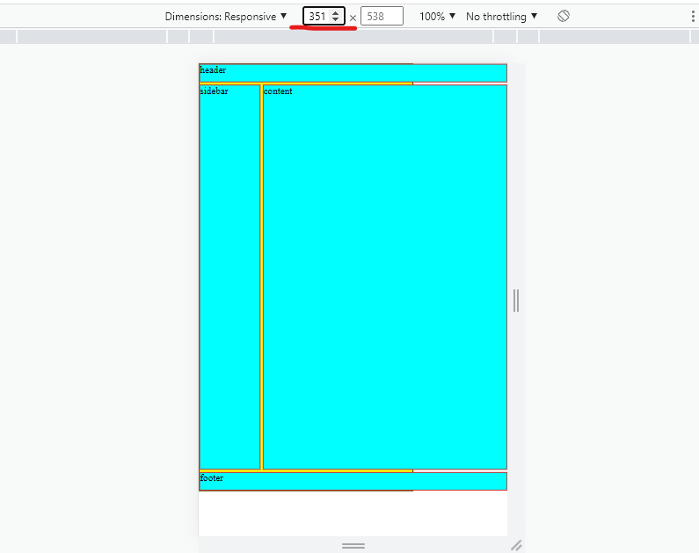

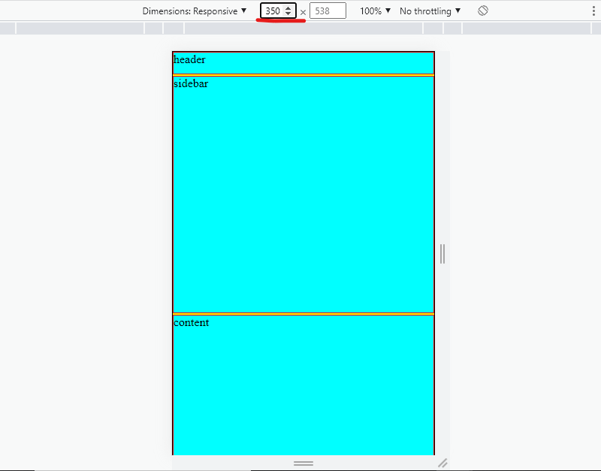

Nested Grid

Html

<!DOCTYPE html>

<html lang="en">

<head>

    <meta charset="UTF-8">

    <meta http-equiv="X-UA-Compatible" content="IE=edge">

    <meta name="viewport" content="width=device-width, initial-scale=1.0">

    <title>Document</title>

    <link rel="stylesheet" href="/Html/h8.css">

</head>

<body>

    <div class="container">

        <div class="box" id="header">header</div>

        <div class="box" id="sidebar">sidebar</div>

        <div class="box" id="content">

                <div class="childGrid">

                    <div class="element">img1</div>

                    <div class="element">img2</div>

                    <div class="element">img3</div>

                    <div class="element">img4</div>

                </div>

        </div>

        <div class="box" id="footer">footer</div>

    </div>

</body>

</html>

Css

*{

    margin: 0px;

    padding: 0px;

    box-sizing: border-box;

}

.container{

    border: 1px solid black;

    background-color: yellow;

    height: 700px;

    width: 510;

    display: grid;

    grid-template-rows: 30px 1fr 30px;

    grid-template-columns: 100px 400px;

    grid-gap: 4px;

    grid-template-areas:

    "hd hd"

    "side main"

    "ft ft";

}

.box{

    border: 1px solid red;

    background-color: aqua;

}

#header{

    grid-area: hd;

}

#sidebar{

    grid-area: side;

}

#content{

    grid-area: main;

}

#footer{

    grid-area: ft;

}

.childGrid{

    height: 100%;

    width:100%;

    display: grid;

    grid-template-columns: 1fr 1fr;

    grid-template-rows: 1fr 1fr;

    grid-gap: 5px;

}

.element{

    border: 1px solid green;

    background-color: hotpink;

}

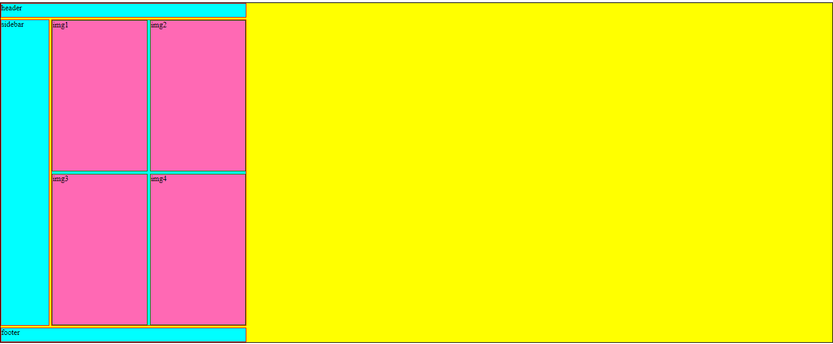

CSS Functions, Variables, Transitions & Animations

Local var()

Html

<!DOCTYPE html>

<html lang="en">

<head>

    <meta charset="UTF-8">

    <meta http-equiv="X-UA-Compatible" content="IE=edge">

    <meta name="viewport" content="width=device-width, initial-scale=1.0">

    <title>Document</title>

    <link rel="stylesheet" href="/Html/h9.css">

</head>

<body>

    <div class="container">

        <div class="box">Box1</div>

        <div class="box">Box2</div>

        <div class="box">Box3</div>

        <div class="box">Box4</div>

    </div>

</body>

</html>

.container{

    border: 1px solid green;

    background-color:violet;

    height: 300px;

    width: 300px;

}

.box{

    border: 1px solid darkred;

    color: purple;

}

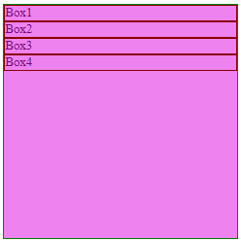

Html part same ,only change in css

.container{

    border: 1px solid green;

    background-color:violet;

    height: 300px;

    width: 300px;

}

.box{

    border: 1px solid darkred;

    color: purple;

    --lime:#00FF00;

    color:var(--lime)

}

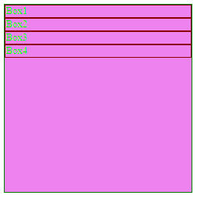

Global variable

Css

:root{

    --seagreen:#2E8B57;

}

.container{

    border: 1px solid green;

    background-color:violet;

    height: 300px;

    width: 300px;

    background-color: var(--seagreen);

}

.box{

    border: 1px solid darkred;

    color: purple;

    --lime:#00FF00;

    color:var(--lime)

}

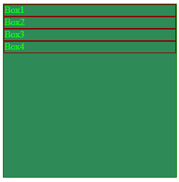

Transitions in CSS

Html

<!DOCTYPE html>

<html lang="en">

<head>

    <meta charset="UTF-8">

    <meta http-equiv="X-UA-Compatible" content="IE=edge">

    <meta name="viewport" content="width=device-width, initial-scale=1.0">

    <title>Document</title>

    <link rel="stylesheet" href="/Html/h10.css">

</head>

<body>

    <div class="container">

        <div class="box">Box1</div>

    </div>

</body>

</html>

Css

.container{

    height: 500px;

    width: 500px;

    background-color: green;

    border: 3px solid red ;

    display: flex;

}

.box{

    height: 150px;

    width: 150px;

    background-color:aqua;

    border: 2px solid orange ;

    margin: 20px;

transition: 2s;

}

.box:hover{

    background-color: magenta;

}

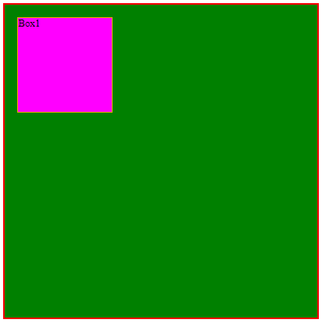

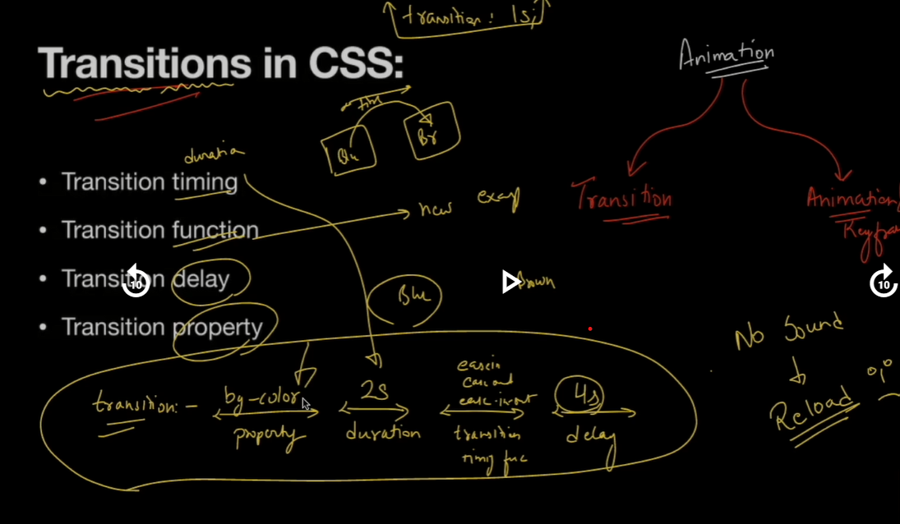

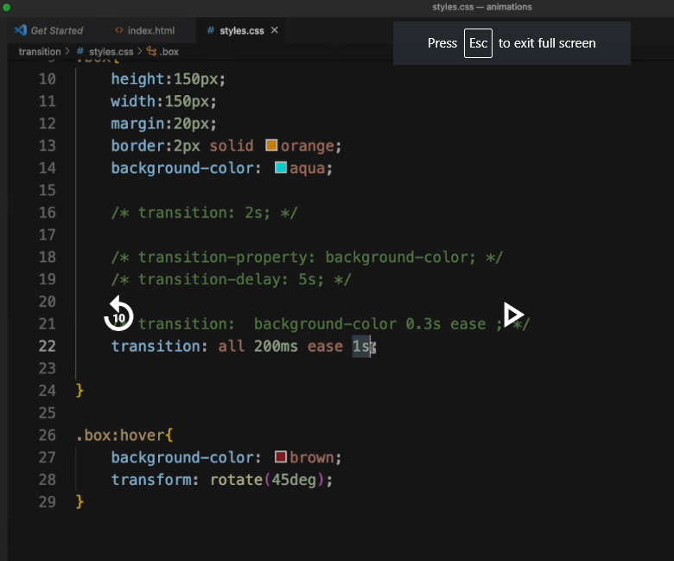

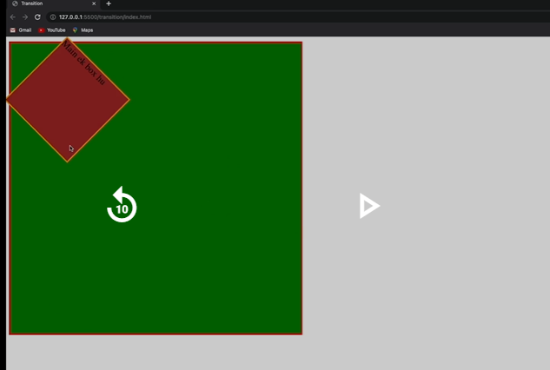

Key frame

Html

<!DOCTYPE html>

<html lang="en">

<head>

    <meta charset="UTF-8">

    <meta http-equiv="X-UA-Compatible" content="IE=edge">

    <meta name="viewport" content="width=device-width, initial-scale=1.0">

    <title>Document</title>

    <link rel="stylesheet" href="/Html/h11.css">

</head>

<body>

    <div class="container">

        <div class="box">Box1</div>

    </div>

</body>

</html>

Css

.container{

    width: 100%;

    height: 214px;

    background-color: yellow;

    border: 2px solid red;

}

.box{

    width: 212px;

    height: 212px;

    background-color: aqua;

    border: 2px solid green;

    animation-name: anandkj;

    animation-duration: 3s;

    animation-iteration-count: 4;

    animation-timing-function: ease-in;

    animation-delay: 1s;

}

@keyframes anandkj{

    from{

        width: 212px;

    }

    to{

        width: 800px;

    }

}

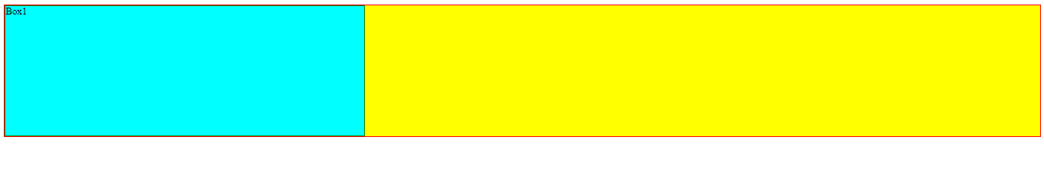

Animation & Responsiveness 26/8/23

CSS Functions, Variables, transitions & Animations [HD]

Transitions in Css :

Html code

<!DOCTYPE html>

<html lang="en">

<head>

    <meta charset="UTF-8">

    <meta name="viewport" content="width=device-width, initial-scale=1.0">

    <title>Document</title>

    <link rel="stylesheet" href="/Transitions/style.css">

</head>

<body>

    <div class="container">

        <div class="box1">Box 1</div>

    </div>

</body>

</html>

Css code

.container{

    height:500px;

    width:500px;

    background-color: green;

    border:3px solid red;

    display: flex;

}

.box1{

    height:150px;

    width:150px;

    margin: 20px;

    background-color: orange;

    border:3px solid aqua;

}

.box1:hover{

     background-color: brown;

}

Output:

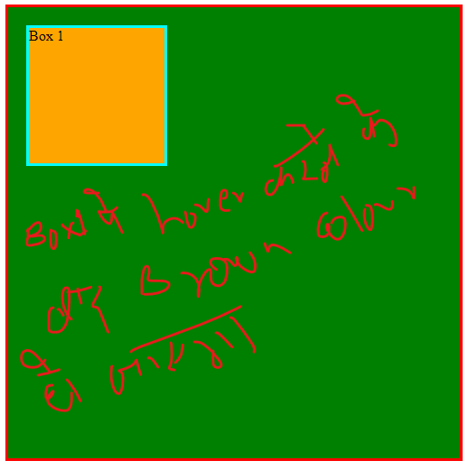

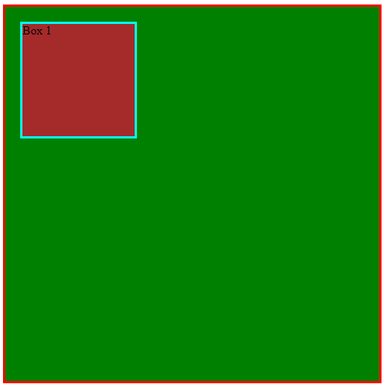

1) transitions

Html code same

Css code :

.container{

    height:500px;

    width:500px;

    background-color: green;

    border:3px solid red;

    display: flex;

}

.box1{

    height:150px;

    width:150px;

    margin: 20px;

    background-color: orange;

    border:3px solid aqua;

    transition: 2s;

}

.box1:hover{

     background-color: brown;

}

Output:

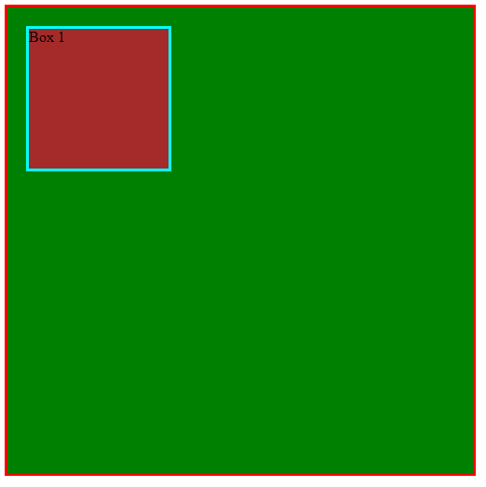

Mouse hover karne ke baad background color change ho jayega jo ki 2 seconde lega

Html part same

Css code :

.container{

    height:500px;

    width:500px;

    background-color: green;

    border:3px solid red;

    display: flex;

}

.box1{

    height:150px;

    width:150px;

    margin: 20px;

    background-color: orange;

    border:3px solid aqua;

    transition: transform 1s ease 3s;

}

.box1:hover{

    transform: rotate(45deg);

}

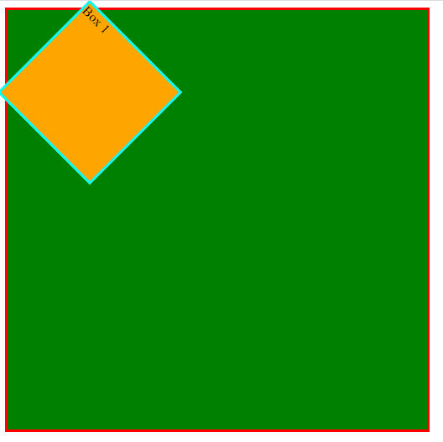

Html part same

Css code

.container{

    height:500px;

    width:500px;

    background-color: green;

    border:3px solid red;

    display: flex;

}

.box1{

    height:150px;

    width:150px;

    margin: 20px;

    background-color: orange;

    border:3px solid aqua;

    transition: all 5s ease ;

}

.box1:hover{

    transform: rotate(45deg);

    background-color: brown;

}

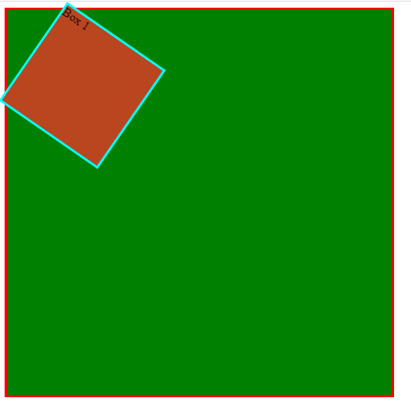

Html part same

Css code

.container{

    height:500px;

    width:500px;

    background-color: green;

    border:3px solid red;

    display: flex;

}

.box1{

    height:150px;

    width:150px;

    margin: 20px;

    background-color: orange;

    border:3px solid aqua;

    transition: transform 1s ease-in ;

}

.box1:hover{

    transform: translateX(500px);

}

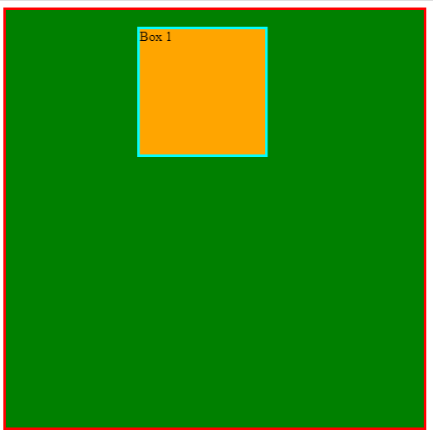

Animation properties

Html code

<!DOCTYPE html>

<html lang="en">

<head>

    <meta charset="UTF-8">

    <meta name="viewport" content="width=device-width, initial-scale=1.0">

    <title>Document</title>

    <link rel="stylesheet" href="/Transitions/style1.css">

</head>

<body>

    <div class="container">

        <div class="box1">box1</div>

    </div>

</body>

</html>

Css code

.container{

    height: 100%;

    width: 100%;

    background-color: yellow;

    border: 3px solid red;

}

.box1{

    height: 212px;

    width: 212px;

    background-color: green;

    border-color: brown;

    animation-name: anandkumar;

    animation-duration: 3s;

    animation-iteration-count: 4;

    animation-timing-function: ease-in;

    animation-delay: 1s;

}

@keyframes anandkumar {

    from {

        width: 212px;

    }

    to{

        width: 900px;

    }

}

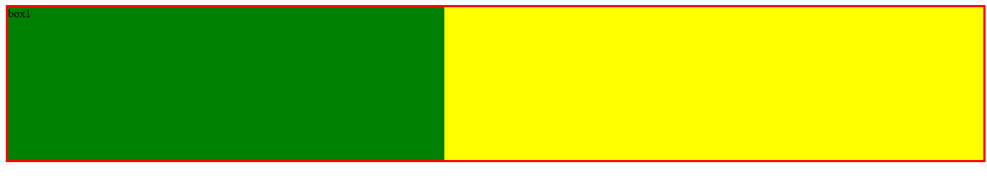

Html part same

Css code

.container{

    height: 100%;

    width: 100%;

    background-color: yellow;

    border: 3px solid red;

}

.box1{

    height: 212px;

    width: 212px;

    background-color: green;

    border-color: brown;

    animation-name: anandkumar;

    animation-duration: 3s;

    animation-iteration-count: 4;

    animation-timing-function: ease-in;

    animation-delay: 1s;

    animation-direction: alternate;

}

@keyframes anandkumar {

    0% {

        width: 212px;

        background-color: orange;

    }

    45%{

        width: 35%;

        background-color: white;

    }

    100%{

        width: 100%;

        background-color: green;

    }

}

